**Getting Started**

**Get to Know the Panel**

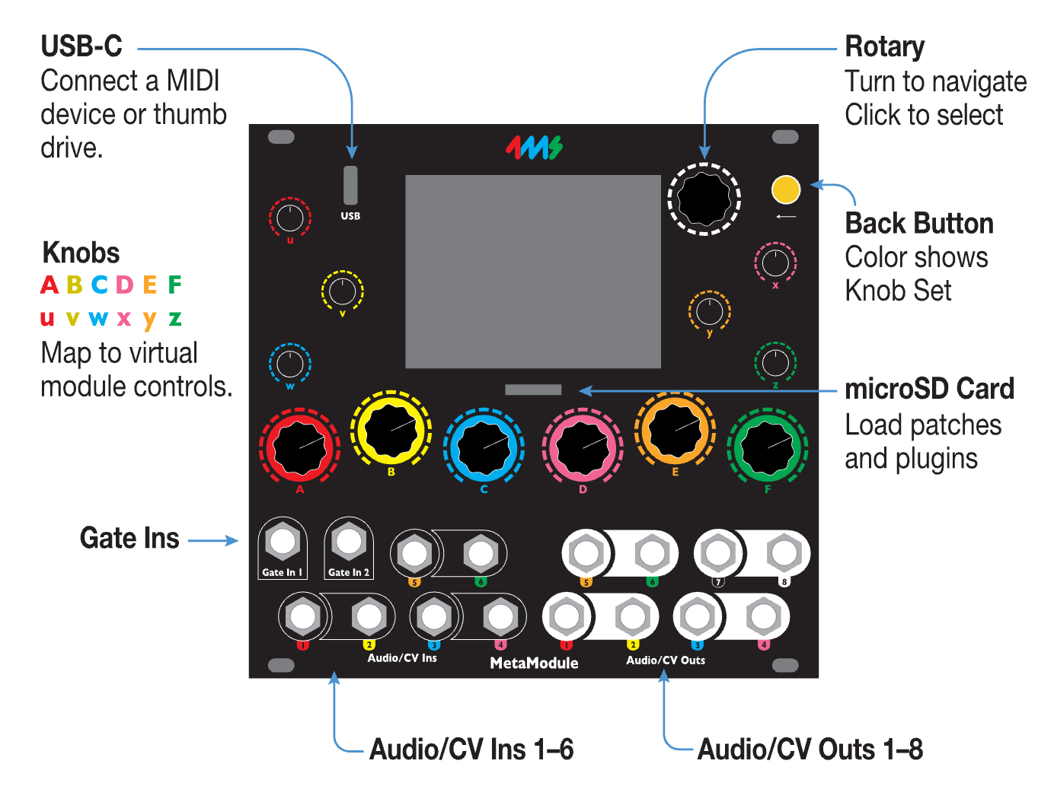

**Connect the power cable**

* **Attach the power cable to the MetaModule, red stripe down**
  + The other end of the cable connects to your Eurorack power supply.

[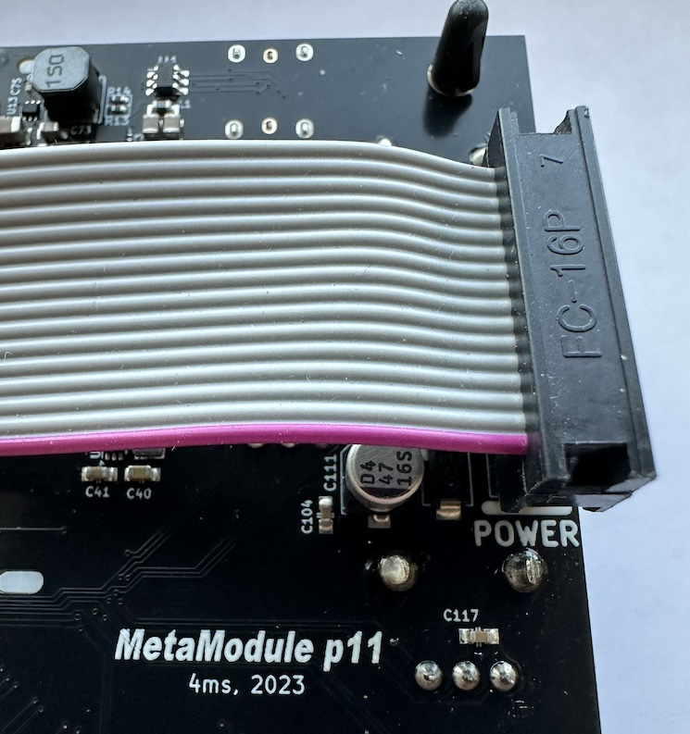](https://metamodule.info/docs/img/power-header.jpg)

**How to Play a Patch**

* **1. Click Load Patch in the Main Menu**

[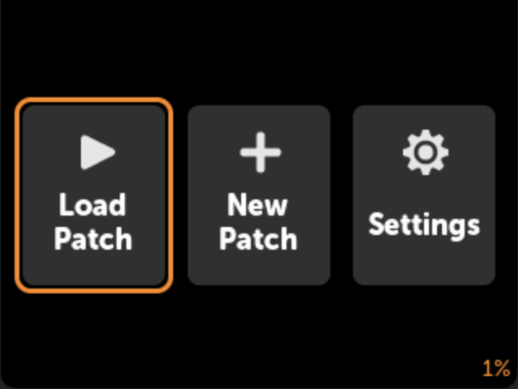](https://metamodule.info/docs/img/main-menu-load.png)

* **2. Click on a patch**

[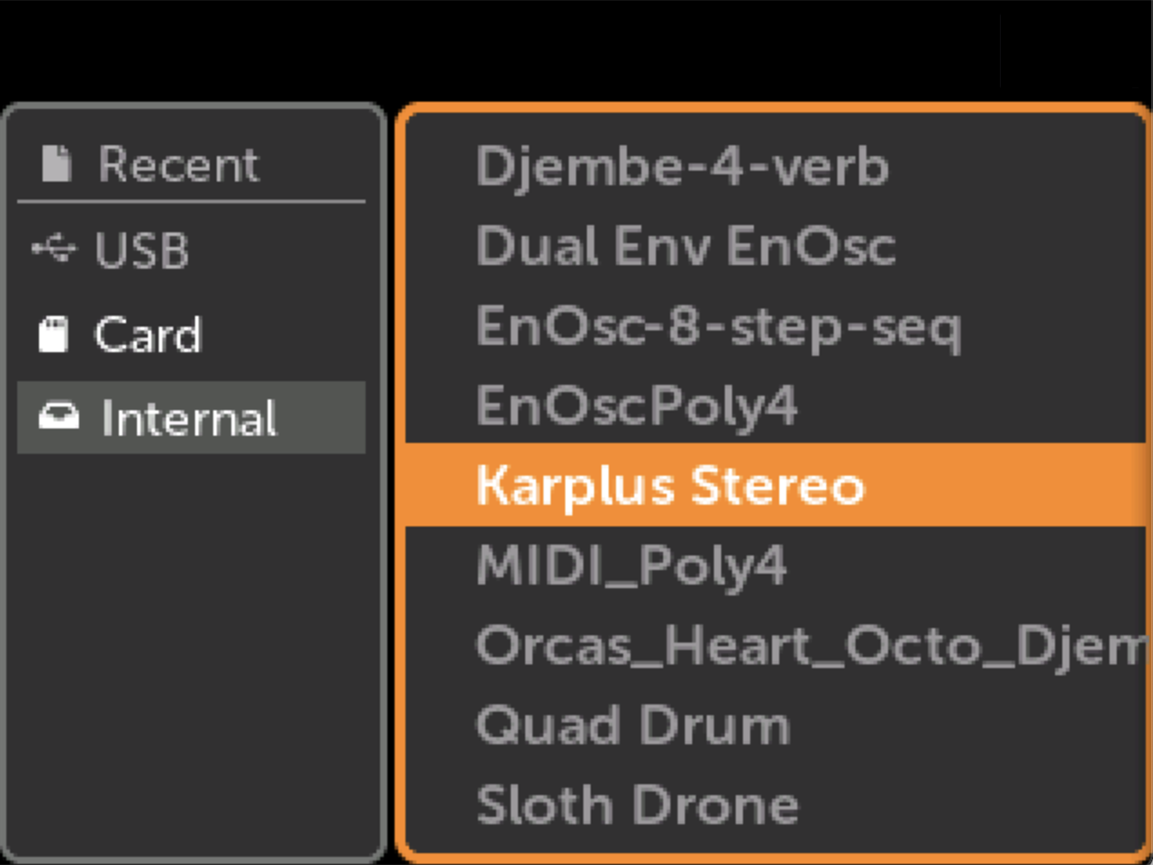](https://metamodule.info/docs/img/patch-sel.png)

* **3. Click Play icon**

[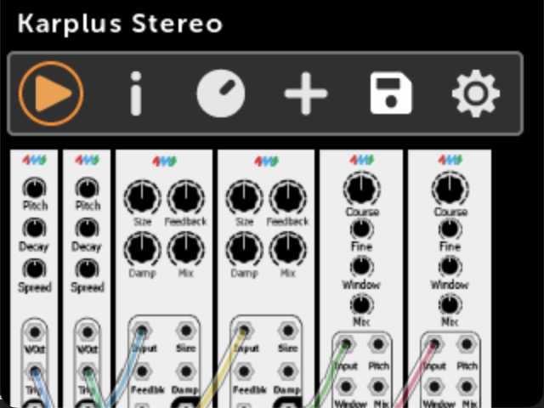](https://metamodule.info/docs/img/patch-view-karplus.png)

**How to Create a New Patch**

* **1. Click New Patch in the Main Menu**

[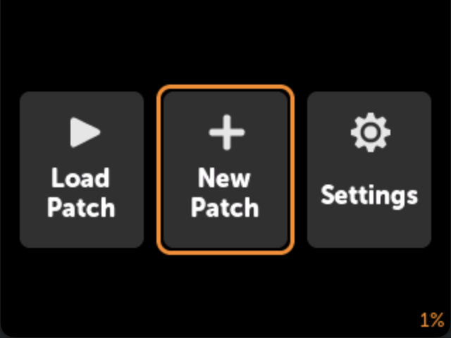](https://metamodule.info/docs/img/main-menu-new.png)

* **2. Pick a module to add to the patch**

For this example, we'll use the Ensemble Oscillator (EnOsc) from 4ms Company.

Click once to view just the panel, then click again to add it.

[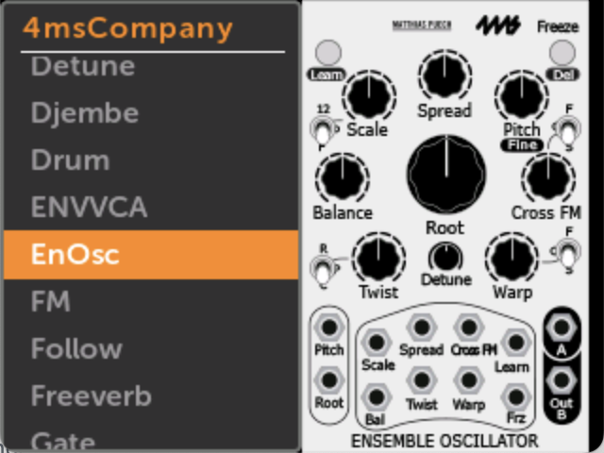](https://metamodule.info/docs/img/module-list-enosc.png)

* **3. Click on the module**

[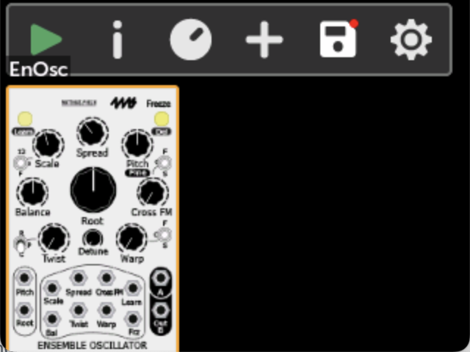](https://metamodule.info/docs/img/patchview-enosc.png)

* **4. Click the Action Menu icon**

[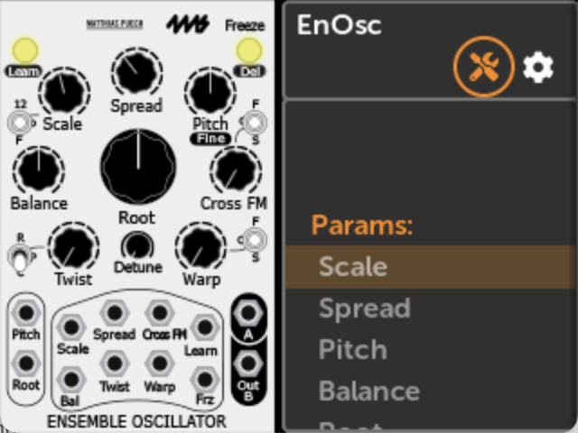](https://metamodule.info/docs/img/enosc-action-icon.png)

* **5. Select Auto-Map**

This will map physical knobs and jacks to the EnOsc's virtual knobs, switches and jacks.

[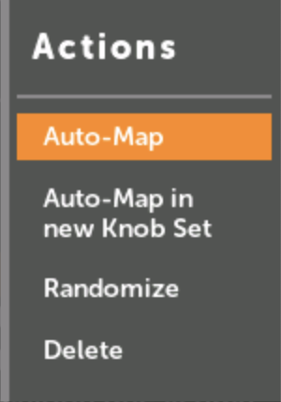](https://metamodule.info/docs/img/auto-map-menu.png)

* **6. Play!**

Patch Audio Outs 1 and 2 on the MetaModule to your speakers and twist the MetaModule knobs to control the sound. Patch modulation sources into the input jacks, if you wish.

Scroll to see the mappings, or view all of them at once in Knob Set View.

You can add more modules by clicking the + icon in the button bar, and repeat from step 2.

[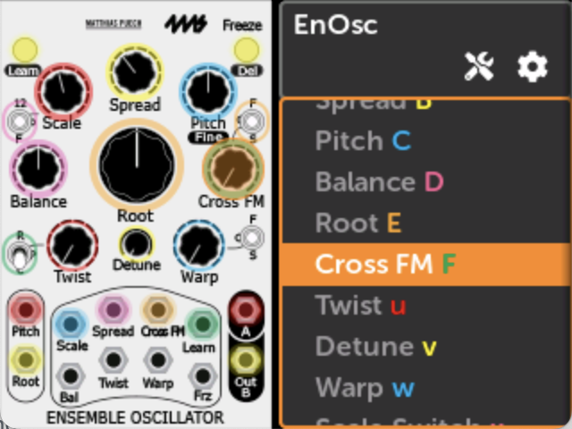](https://metamodule.info/docs/img/enosc-mapped.png)

**How to Update Firmware**

* **1. Click Settings in the Main Menu**

[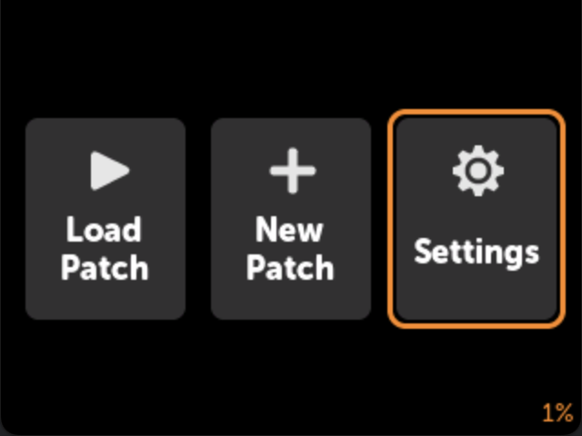](https://metamodule.info/docs/img/main-menu-settings.png)

* **2. Click Update**

[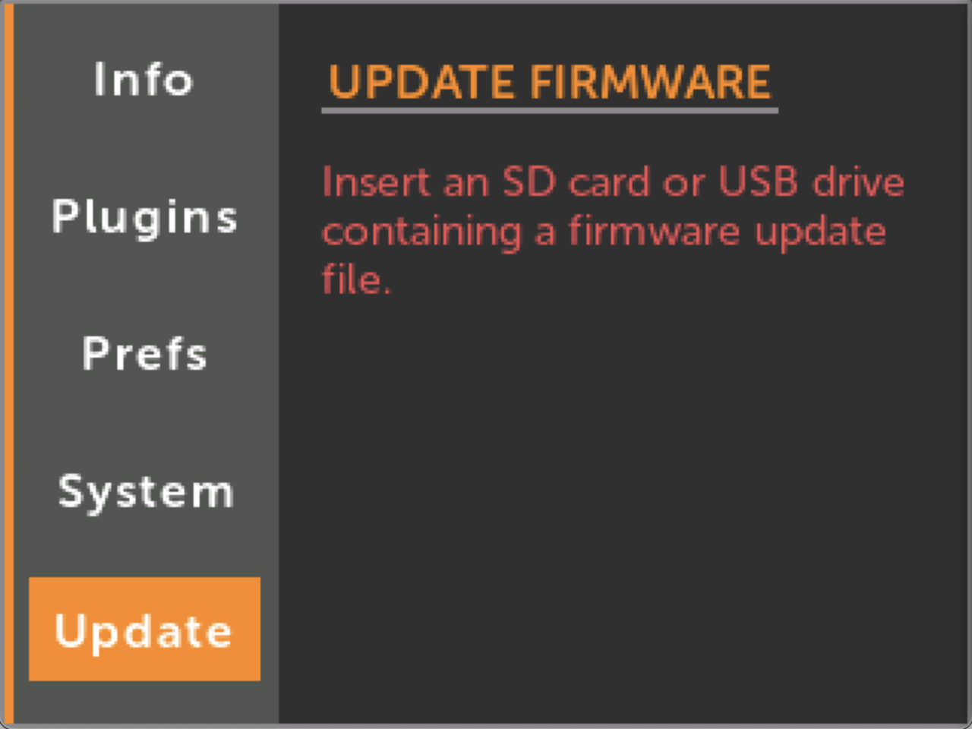](https://metamodule.info/docs/img/settings-update.png)

* **3. Download the firmware to a USB drive or SD Card**

Use the [Download](https://metamodule.info/downloads) link above.

Then save the metamodule-firmwarefolder on your drive.

[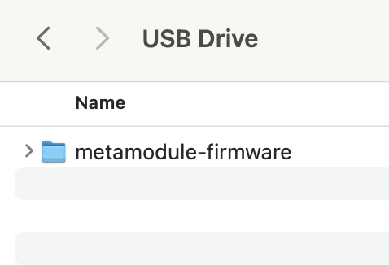](https://metamodule.info/docs/img/macos-firmware-disk.png)

* **4. Insert the drive into the MetaModule and click Update Firmware**

The drive will be automatically detected.

You must leave the module powered on the entire time it is updating.

It takes about a minute.

[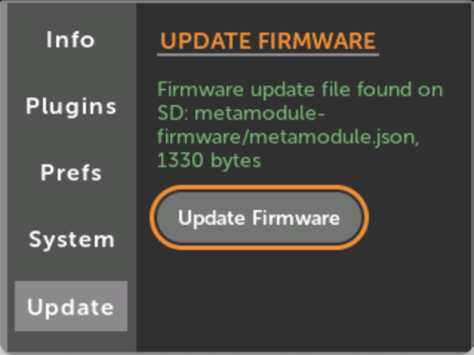](https://metamodule.info/docs/img/firmware-update-button.png)

Note: if you are upgrading firmware and plugins at the same time, always upgrade the firmware first. This is because it's possible that the new plugins will need the new firwmare in order to run. An easy way to make sure you're doing it right is to copy the new plugins and firmware onto a disk (SD card or USB). Then power up with all disks removed so that the plugin pre-loader does not load any plugins. Then insert the disk and upgrade firmware normally. Finally, reboot with the disk still inserted.

**Using the MetaModule: Knobs**

**How to View Knob and Jack Mappings**

* **1. Click the Knob icon in the button bar**

[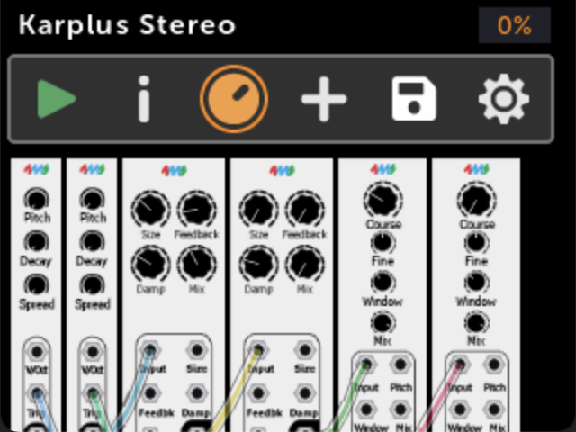](https://metamodule.info/docs/img/patch-view-knobset-icon.png)

* **2. Knob mappings are shown**

This is a "Knob Set" (see below).

Turn some physical knobs and watch the knobs on the screen turn (the patch must be playing).

Click Jacks to view jack mappings

[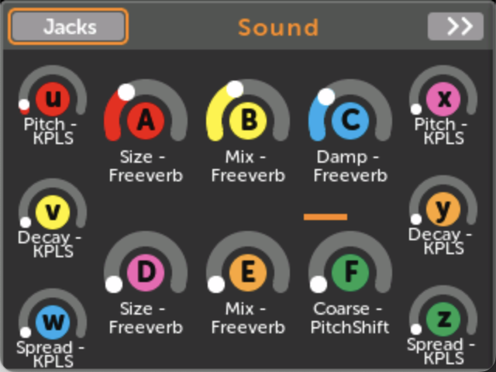](https://metamodule.info/docs/img/knobset-karplus-jackicon.png)

* **3. Jack mappings are shown**

[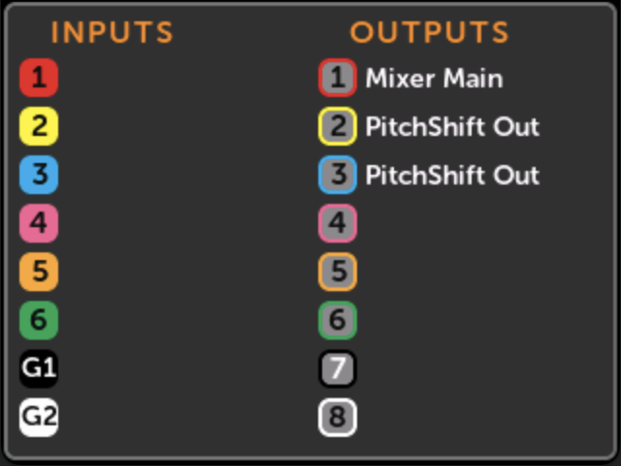](https://metamodule.info/docs/img/jackmap-karplus.png)

**Knob Sets**

* A Knob Set is a group of knob mappings. Each Knob Set maps the 12 physical knobs to virtual module controls. For example, a patch might have a Knob Set for each module. Or there might be a Knob Set for controlling various timbre parameters, another Knob Set for controlling rhythmic elements, and another for overall mix.
* A patch can have up to eight Knob Sets, but only one Knob Set can be active at a time.
* A single physical knob can be mapped to up to 8 virtual knobs in a Knob Set. See [Multi-maps](https://metamodule.info/docs/using_metamodule.html#mapping-to-more-than-one-knob-multi-maps)

How to Use a Different Knob Set

From the Knob Set page:

* **1. Click >> to view the next Knob Set**

If there is only one Knob Set in the patch, the >> button will not appear.

[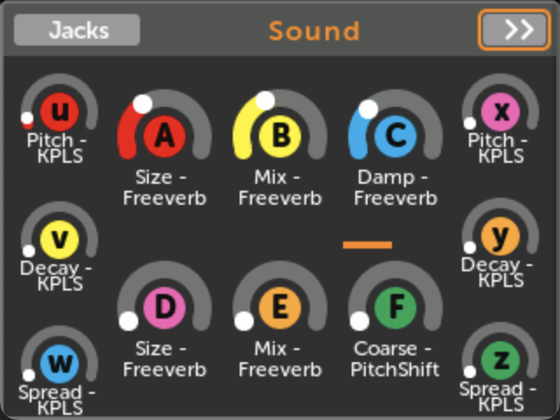](https://metamodule.info/docs/img/knobset-karplus.png)

* **2. Click Use to activate a Knob Set**

Now the physical knobs will control the parameters mapped in the new Knob Set.

[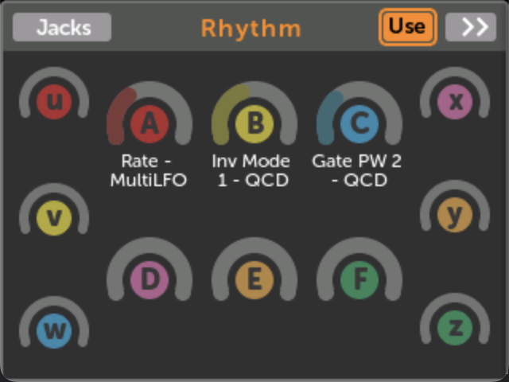](https://metamodule.info/docs/img/knobset-use.png)

**Knob Set Shortcut**

A fast way to change Knobs Sets is to **hold down the Back button and turn the encoder**.

A pop-up will tell you the name of the Knob Set that was just made active.

The Back button's color will always indicate the Knob Set number:

**1**

**2**

3

4

5

6

7

8

Creating a new Knob Set

You can create a new knob set in several ways:

* With VCV Rack, when you make the patch. See [Creating Knob Sets in VCV Rack](https://metamodule.info/docs/using_rack.html#creating-knob-sets-in-vcv-rack)
* By clicking (new knobset) when you creating a new knob mapping (see next section)
* By selecting Auto-map knobs (new Knob Set) from the module [Action menu](https://metamodule.info/docs/action_menu.html#auto-map-knobs-new-knob-set).

Changing a Knob Set name

From the Knob Set page:

* **1. Click on the knob set name**

[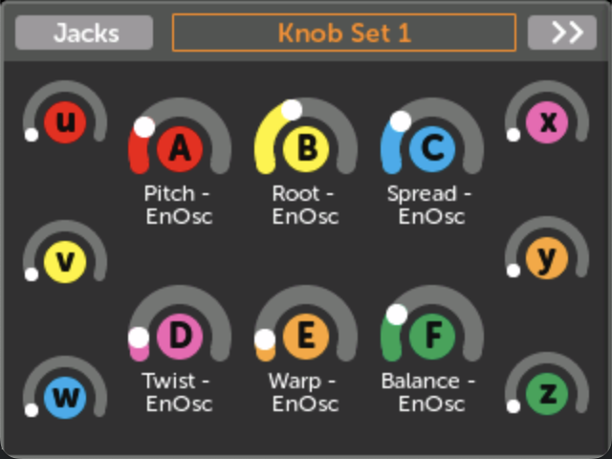](https://metamodule.info/docs/img/knobset-name.png)

* **2. Type a new name**

Click the check mark to save your changes, or press the Back button to cancel.

[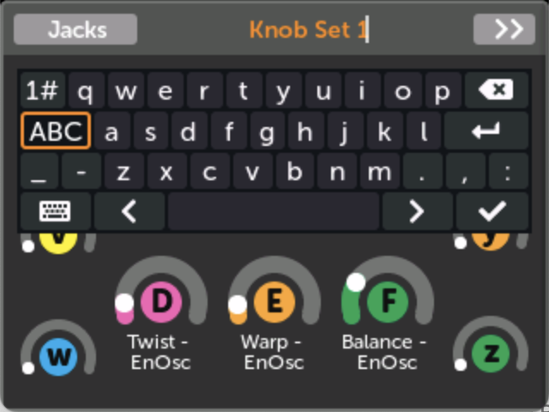](https://metamodule.info/docs/img/edit-knobset-name.png)

**Creating a new Knob Mapping or MIDI Mapping**

From the Patch View page:

* **1. Open a module and click a control**

[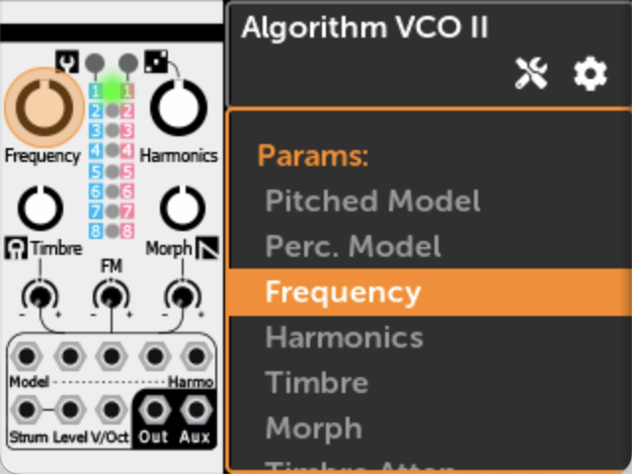](https://metamodule.info/docs/img/plaits-freq-knob.png)

* **2. Click on a Knob Set that doesn't already have a mapping**

If you want to create a new Knob Set, click (new knobset)

If you want to map a MIDI CC or Note to this knob, click MIDI

[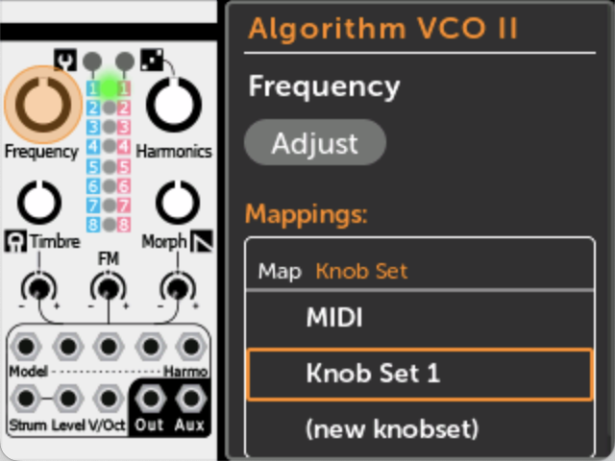](https://metamodule.info/docs/img/plaits-mapping-pane.png)

* **3. Wiggle the knob you want to map to**

If you're mapping MIDI, then send a MIDI Note or CC message. You may select a MIDI Channel if you wish.

Knob:[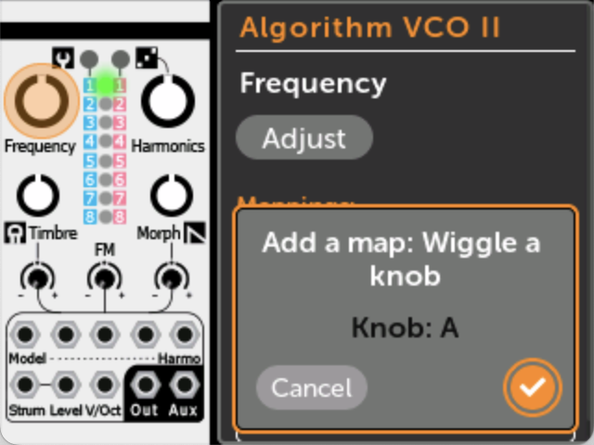](https://metamodule.info/docs/img/plaits-mapping-add.png)MIDI:[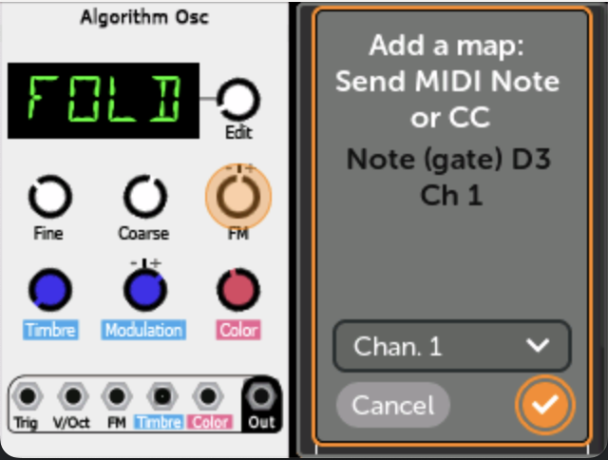](https://metamodule.info/docs/img/midi-mapping-add.png)

* **4. Click OK. It's mapped!**

If you want to adjust the minimum and maximum values of the mapping, or give the mapping a name, see [Edit a Knob Mapping](https://metamodule.info/docs/using_metamodule.html#editting-a-knob-mapping).

[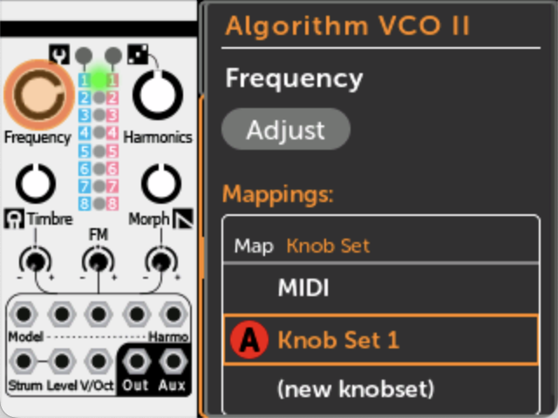](https://metamodule.info/docs/img/plaits-mapping-done.png)

How MIDI param mappings work

You can map MIDI CC or MIDI Note Gates to parameters such as knobs, buttons, switches, etc.

The parameter value is always updated immediately when a MIDI message is received, regardless of the current Knob Catchup mode.

On the [Edit Mapping](https://metamodule.info/docs/using_metamodule.html#editting-the-midi-channel-of-a-midi-mapping) page, each MIDI mapping can be set to respond to all MIDI channels, or just a particular MIDI channel.

The MIN and MAX sliders determine the range of the mapping in the same way that they do for panel knob mappings. For MIDI CC mappings, this means a CC value of 0 will set the parameter to the value set by the MIN slider, and a CC value of 127 sets it to the MAX slider's value. For MIDI Note Gate mappings, the note can only be on or off, so the parameter will be set to the MIN or MAX slider value. Additionally, for MIDI Note Gate mappings you can enable Toggle mode to make the parameter change value each time a note is played. See [MIDI Note toggle mode](https://metamodule.info/docs/using_metamodule.html#midi-note-gate-toggle-mode)

Note that while you can only map MIDI CC and Note Gates to parameters, you can map any MIDI message to input jacks: see [Patching To MIDI](https://metamodule.info/docs/using_metamodule_jacks.html#midi-input).

--

**MIDI Feedback**

MIDI Feedback, also known as "bi-directional MIDI", is a feature that allows a MIDI controller to stay in sync with the MetaModule. When this is enabled, the MetaModule will send MIDI CC, pitch wheel, and Note on/off messages back to the controller whenever a parameter changes value. When a patch is loaded, the MetaModule will send the value of all MIDI-mapped parameters. If the MIDI controller supports MIDI Feedback, then it will update its display or internal state with the new value.

For example, if you map a CC to the Pitch knob of your VCO, then when you load that patch, a feedback-aware MIDI controller will jump to the current value of the pitch, perhaps by displaying this value on a screen or even by turning a motorized knob like the Roto-Control does.

As you play the patch, if you adjust the VCO's pitch knob manually (using the Adjust button) or by mapping a panel knob to the Pitch knob, then the MIDI controller will stay in sync with these new parameter values. Also, say the module happens to have advanced features such as scale quantization, such that when you select a scale the Pitch knob jumps to the closest note. The MetaModule will still keep the MIDI controller in sync even if the Pitch knob changed indirectly (e.g. because you selected a new quantization scale or a new preset).

If you need to re-send all MIDI-mapped values to the controller, for example if you reset the controller after loading the patch, simply pause and unpause the patch playback. This will send the current value of all MIDI-mapped parameters.

* **To enable or disable MIDI Feedback, check the box in Settings > Prefs > MIDI:**

By default, MIDI Feedback is enabled starting in firmware v2.0.9.

[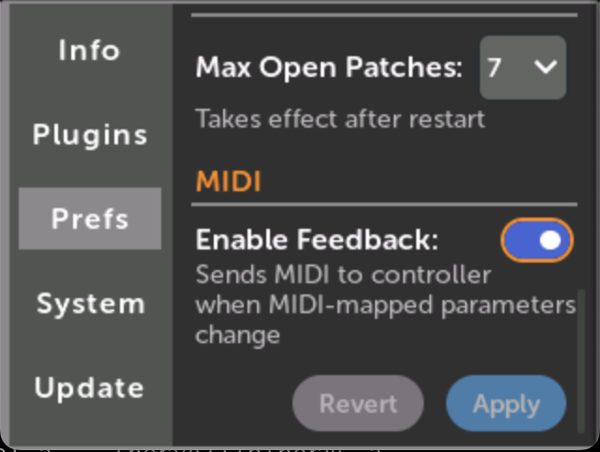](https://metamodule.info/docs/img/midi-feedback.png)

**Editting a Knob Mapping**

From the Knob Set page:

* **1. Click on a mapping...**

[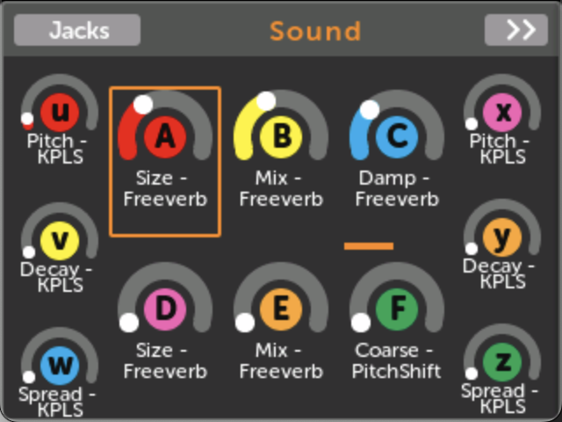](https://metamodule.info/docs/img/knobset-karplus-knobA.png)

* **2. ... to go to the Knob View page**

[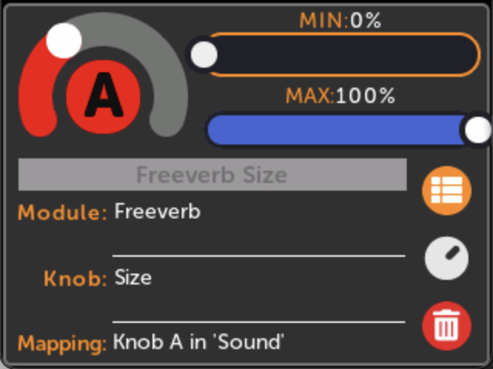](https://metamodule.info/docs/img/knobview.png)

* **3. Click on MIN or MAX to change the range**

When the physical knob is all the way down, the virtual knob will be set to the MIN value. Likewise, when the physical knob is all the way up, the virtual knob will be at the MAX value.

If you set MAX to be less than the MIN, the virtual knob will turn the opposite direction as the physical knob.

[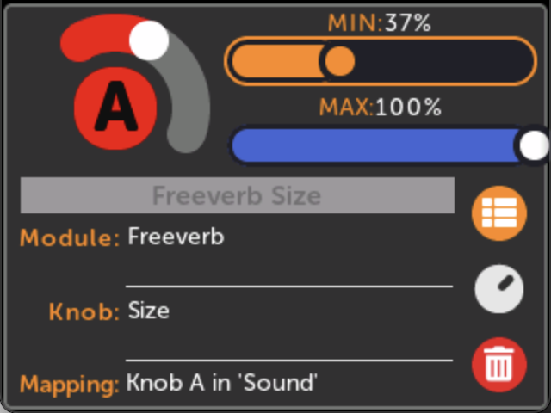](https://metamodule.info/docs/img/knobview-min.png)

* **4. Click on the knob name to type an alias**

An alias is a name you pick for a knob mapping. If this is a multi-map, then the alias will apply to all mappings within the multi-map.

[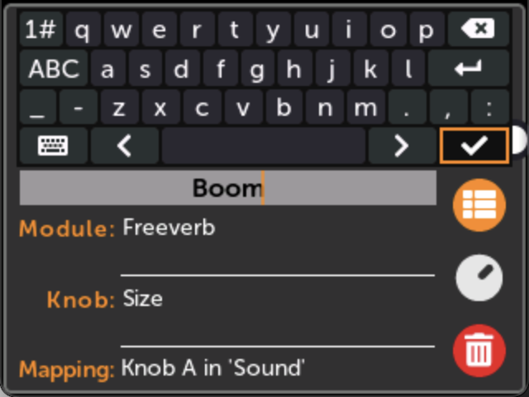](https://metamodule.info/docs/img/knobview-name.png)

**Editting the MIDI Channel of a MIDI Mapping**

From the Module View page:

* **1. Click on the mapped control**

[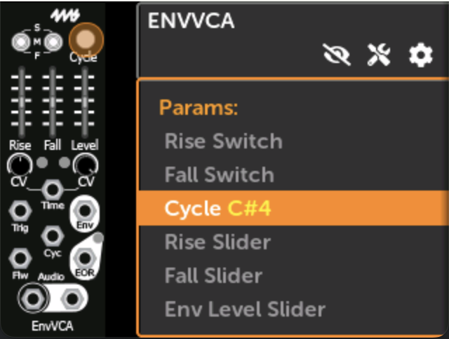](https://metamodule.info/docs/img/module-view-mapping-pane-midi.png)

* **2. Click on the MIDI mapping**

[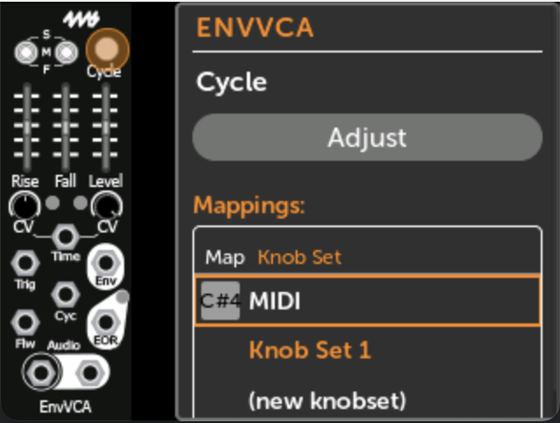](https://metamodule.info/docs/img/module-view-midi-map.png)

* **3. Adjust the MIDI Channel**

You may adjust the MIN/MAX sliders and the mapping name in the same way that you do so for normal knob mappings.

For MIDI Note Gate mappings, you may also change the Toggle mode (see below).

[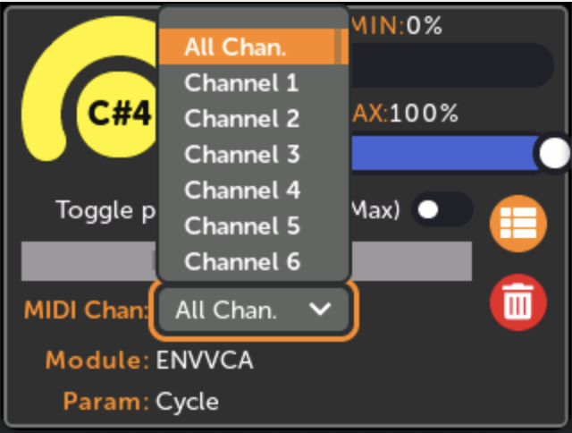](https://metamodule.info/docs/img/midi-map-channel.png)

MIDI Note Gate Toggle mode

When you map a MIDI Note Gate to a parameter, you have two options:

* **MIDI Note Gate: Toggle Enabled**

Each time a matching Note On message is received, the parameter will toggle between the values set by the MIN and MAX sliders. Note Off messages are ignored. This makes the parameter value toggle each time you play the MIDI Note.

*Technical note:* In case the param has changed value since the last MIDI Note message, the MetaModule will set the value to MIN or MAX based on which one the current value is **farther** from.

[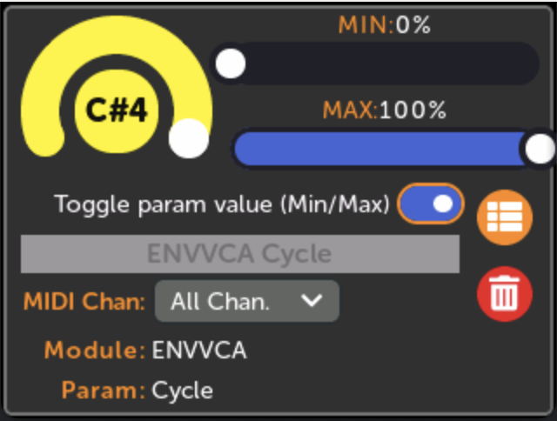](https://metamodule.info/docs/img/midi-map-toggle-on.png)

* **MIDI Note Gate: Toggle Disabled**

When a Note On message for that note is received, the param's value will be set to the value of the MAX slider. When a Note Off message is received, the param will be set to the MIN slider's value.

[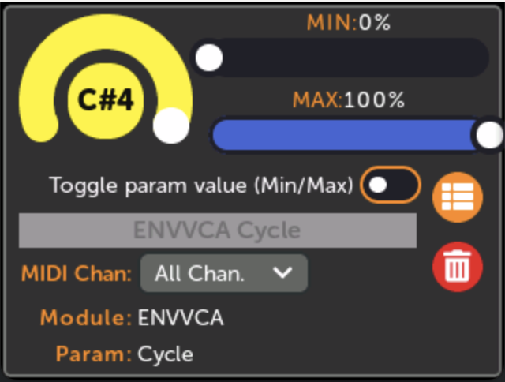](https://metamodule.info/docs/img/midi-map-toggle-off.png)

**Mapping to more than one knob (Multi-maps)**

A single physical knob can be mapped to up to eight virtual knobs. This is known as a "multi-map". As you turn the physical knob, all the mapped virtual knobs will turn. Each virtual knob can have different minimum and maximum values. In this way, mulit-maps allow the MetaModule to act like a macro controller.

For example, if a reverb module has separate wet and dry level knobs, you could map a physical knob to both of these. Then you could set the MIN and MAX values such that as you turn the physical knob up, the dry level will go down, and the wet level will go up, creating a crossfade between the dry and wet signals.

Another example is using multi-maps in a polyphonic patch. One physical knob can control the pitch knobs of all the voices; another physical knob can control the waveshape knobs; another can control the envelope shapes, etc...

Multi-maps exist within a Knob Set. So each Knob Set can have its own set of maps and multi-maps. Since there are a maximum of eight Knob Sets, and each Knob Set has twelve knob multi-maps, and each multi-map can have up to eight virtual knobs, a maximum of 768 virtual knobs can be mapped in a single MetaModule patch.

How to create a multi-map

Multi-maps are created automatically if you create new knob map with a physical knob that's already mapped (in the current knob set). See [Creating a New Knob Mapping](https://metamodule.info/docs/using_metamodule.html#creating-a-new-knob-mapping-or-midi-mapping).

How to view a multi-map

Viewing any module that has a mapping that's a part of a multi-map will display that mapping normally.

If you want to see all the virtual knobs that map to a specific physical knob:

* **1. Click the knob icon to go to the Knob Set page**

[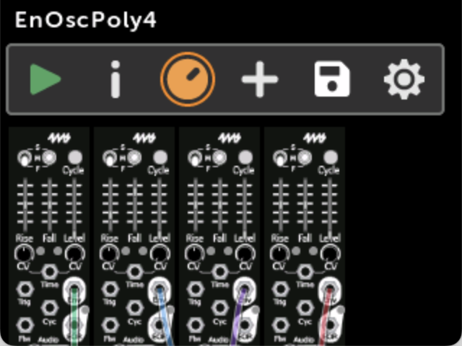](https://metamodule.info/docs/img/patch-enosc4-knobset-icon.png)

* **2. Multi-maps are shown with a scroll bar under the knob**

Scroll left and right to view all the mapped knobs.

[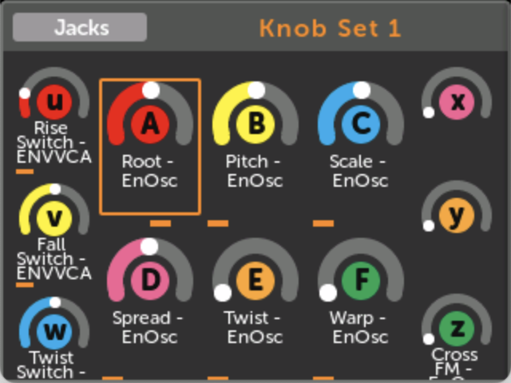](https://metamodule.info/docs/img/knobset-multimap.png)

**Using the MetaModule: Jacks, MIDI, and Cables**

**How to Patch Cables**

There are two types of cables in the MetaModule: cables between virtual modules (also called internal cables), and cables that go to the physical panel jacks (also called Jack Mappings)

*Note: While VCV Rack supports polyphonic cables, only monophonic cables are supported on the current version of the MetaModule*

Patching cables between modules

* **1. Click on a jack, and click New Cable**

You can start a cable from the input or output. If the jack is already patched, then the new cable will "stack" on top of the existing cable (thus acting like a passive mult)

If this is the first cable you're creating this session, a pop-up will remind you of how to patch a cable. Read them and click OK.

[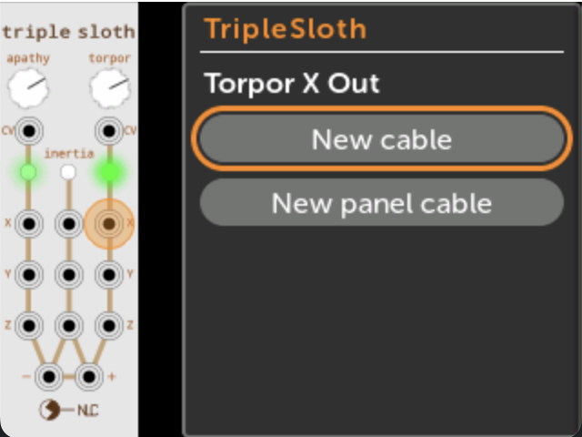](https://metamodule.info/docs/img/new-cable-start.png)

* **2. Navigate to the jack you want to connect to**
  + Find the module you want to patch to, and click on it.
  + Then scroll to the jack you want to patch to, and click on it.

Only valid jacks will be shown. You cannot connect multiple outputs to to an input.

If you want to cancel making a cable, click "Cancel Cable" or press the Back button from the Patch View page.

[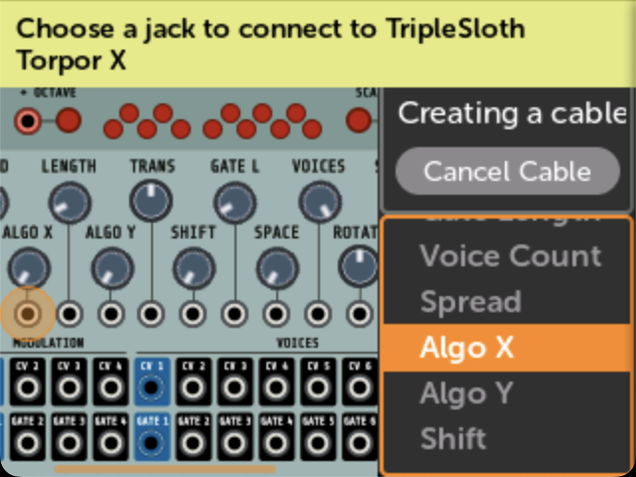](https://metamodule.info/docs/img/new-cable-dest.png)

* **3. Done!**

*Note: Keep in mind that the physical panel Input jacks are treated like outputs. This makes sense if you consider that they send signals to virtual modules. Therefore, if a panel Input (i.e. In 1-6 or GateIn 1-2) is patched to a virtual input jack, then you cannot patch another output to the same virtual input jack (because only one output can drive an input).*

[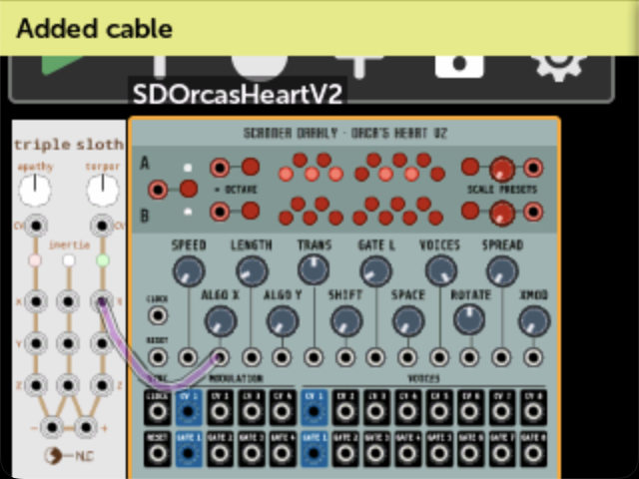](https://metamodule.info/docs/img/new-cable-done.png)

Patching to a panel jack

Patching a virtual module jack to a panel jack is how you map the physical jacks on the MetaModule to virtual module jacks.

* **1. Click on a jack, and click New Panel Cable**

If the jack is already connected to a panel jack, then this button will not be displayed.

[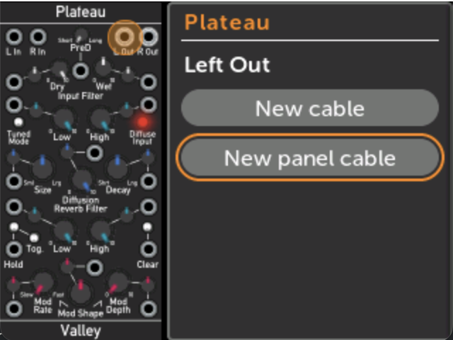](https://metamodule.info/docs/img/new-panel-cable.png)

* **2. Select a panel jack and click Connect**

The drop-down menu will indicate if any panel jacks are already connected:

* + Connecting to a panel Out jack that's already connected to something else will disconnect the existing cable.
  + Connecting to a panel In jack that's already connected to something else will stack on top of the existing cable.

[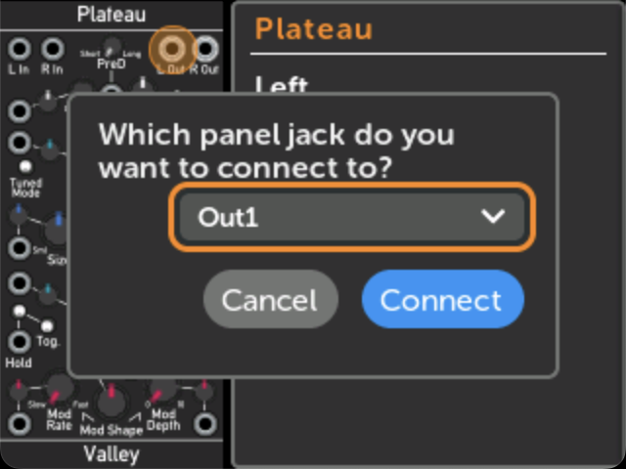](https://metamodule.info/docs/img/new-panel-cable-popup.png)

MIDI Input

You can patch MIDI signals to input jacks in two ways: using MIDI mappings, or using a MIDI-CV module.

**Patching MIDI Input to jacks**

* **1. Click on an input jack, and click New MIDI Map**

If the jack is already connected to a panel jack, then this button will not be displayed.

[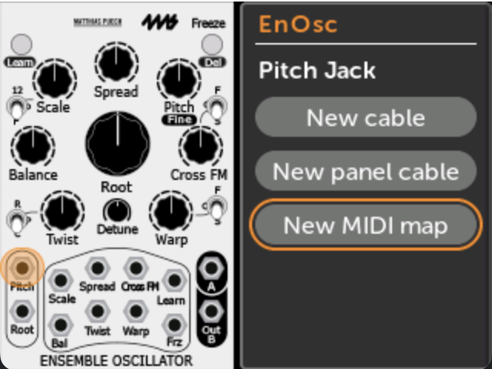](https://metamodule.info/docs/img/enosc-midi-map.png)

* **2. Select a MIDI signal**

Choose from:

* + Note events (keyboard): select Pitch (key number), Gate (note on/off), Velocity, Aftertouch, or Retrigger (multiple note-on). Also select the polyphony channel. The maximum polyphony channel of all the MIDI mappings in the entire patch determines how MIDI note events are parsed.
  + CC: Continuous CV scaled to 0V to 10V. Select a CC number, or send a CC event to "learn" it.
  + Pitch Wheel
  + Gate on Note: fires a gate whenever a particular note is pressed. Select a note or play a note live to "learn" it.
  + Clock: Select the raw MIDI clock (24PPQN) or a divided version of that.
  + Transport: Sends a gate for Start, Stop, and Continue events.
  + Channel: Select "All Channels" or a choose a particular MIDI channel to respond to.

[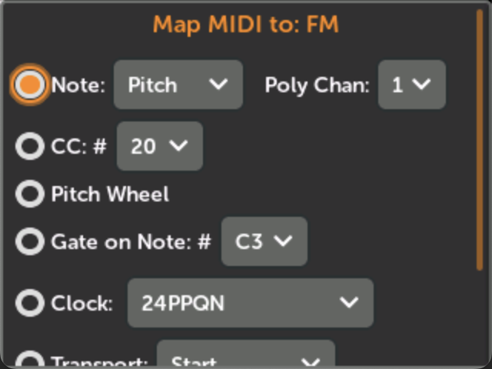](https://metamodule.info/docs/img/midi-map-top.png)

* **3. Click Map to create the mapping**

[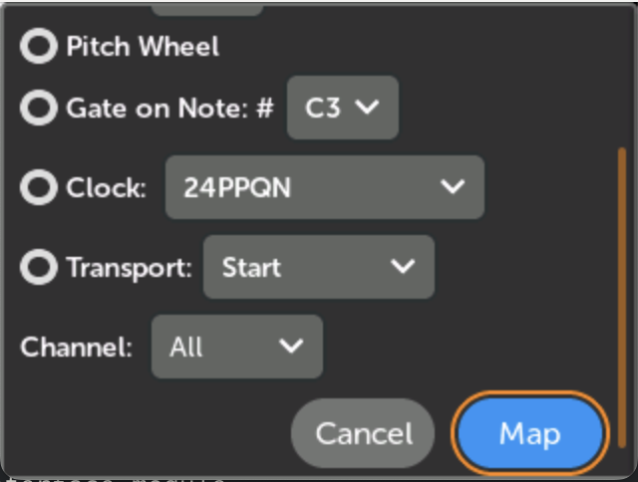](https://metamodule.info/docs/img/midi-map-pw.png)

**Using a MIDI input module**

* **1. Add the RackCore MIDIToCVInterface module**

[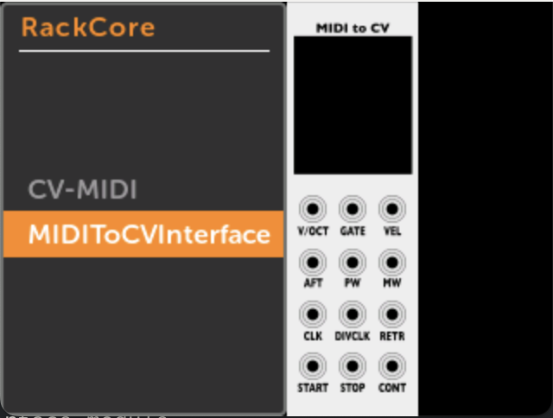](https://metamodule.info/docs/img/rackcore-midi-cv-module.png)

* **2. Patch the jack(s) corresponding to the MIDI signal(s) you want to use**

[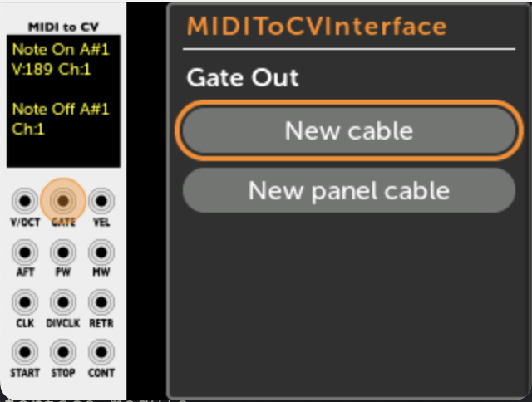](https://metamodule.info/docs/img/rackcore-midi-cv-jack.png)

Patching Outputs to MIDI

To support MIDI Output as a MIDI Host, the MetaModule has the CV-MIDI module in the RackCore brand.

Third-party plugin modules that produce MIDI Output should work, as well.

Note that the MetaModule always acts as a MIDI Host, and never as a MIDI Device.

* **1. Add the RackCore CV-MIDI module**

[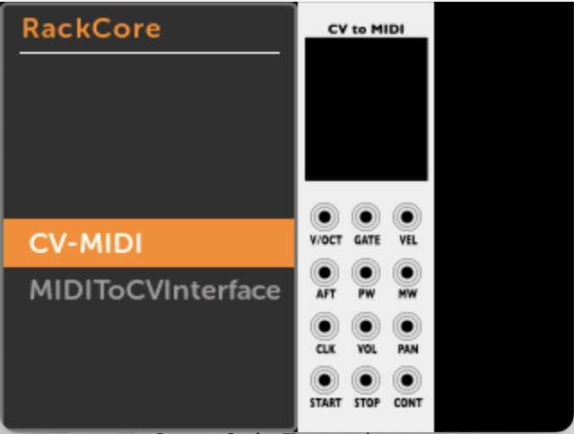](https://metamodule.info/docs/img/rackcore-cv-midi-module.png)

* **2. Patch the CV and gate signals you wish output as MIDI**

A log of MIDI events will appear on the module's screen.

[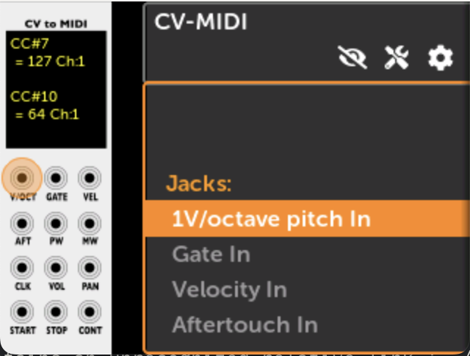](https://metamodule.info/docs/img/rackcore-cv-midi-jacks.png)

Disconnecting a cable (Unpatching or removing a cable)

* **1. Click on a jack, and then click Disconnect**

This will disconnect all cables to this jack.

For stacked cables (one output going to multiple inputs):

* + If the selected jack is an output, then all stacked cables will be removed.
  + If the selected jack is an input, then only the stacked cables that connect to this jack will be removed.

[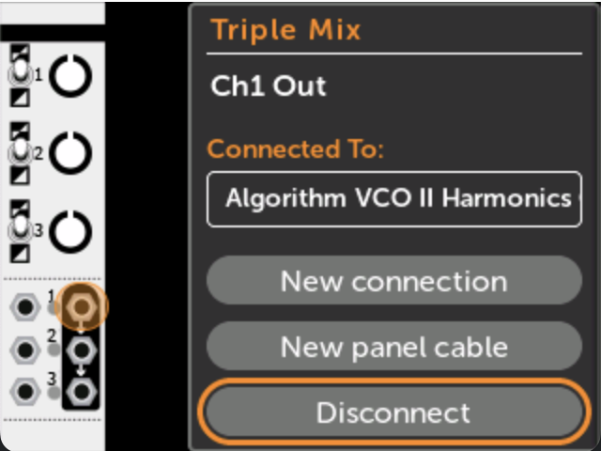](https://metamodule.info/docs/img/disconnect-cable.png)

Following a Cable

You can "follow" a cable to trace the connections between modules.

* **1. Click on a jack, and then click on an item in "Connected To:"**

You will be taken to the jack on the other module.

Clicking on a Panel connection does nothing.

[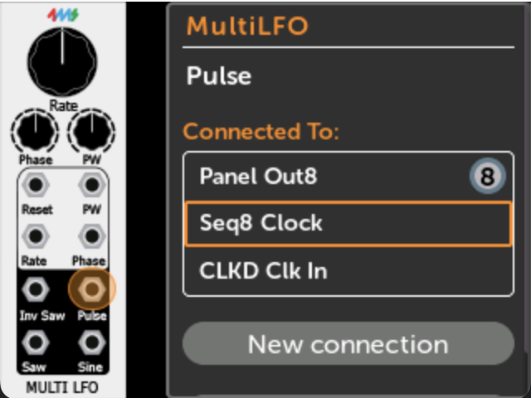](https://metamodule.info/docs/img/connecting-jack.png)

* **2. Module and jack on the other end of the cable will be shown**

You can repeat the process to trace all connections on a jack.

Pressing the Back button will re-trace your steps, first going to the module's list of controls and jacks, and then going back to the previously viewed module.

[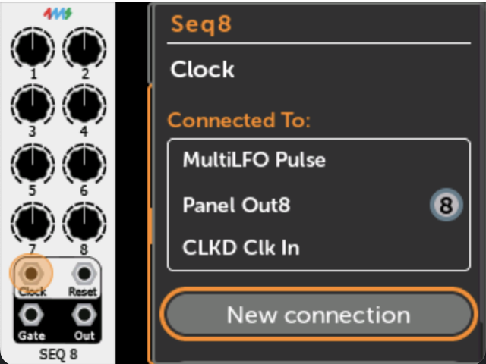](https://metamodule.info/docs/img/connecting-jack-end.png)

**Using Metamodule with Rack**

**What is VCV Rack?**

[VCV Rack](https://vcvrack.com/) is a "Virtual Eurorack Studio" that runs on a Mac, Windows, or Linux computer. There are thousands of free modules available, making it one of the most popular virtual modular platforms. There is a free open-source version, and a paid Pro version.

*VCV Rack is owned and maintained by VCV and is not affiliated with 4ms Company.*

You can create patches on your computer in VCV Rack and play them on the MetaModule. This is the preferred workflow for complex patches involving lots of modules, patch cables and/or mappings.

**Installing the 4ms modules into VCV Rack**

Before you can use VCV Rack to create patches for your MetaModule, you need to install the 4ms modules into VCV Rack on your computer.

* **1. Install from VCV Rack Library**

Go to the 4ms Company page of the [VCV Rack Library](https://library.vcvrack.com/4msCompany)

[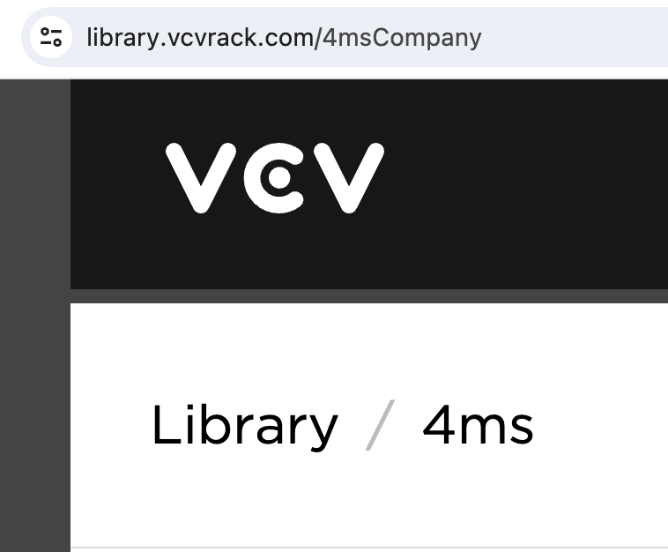](https://metamodule.info/docs/img/vcv-library-webpage.png)

* **2. Click Subscribe**

Click "Subscribe" to add all 4ms modules to your account. Subscribing will also tell the VCV Rack program to check for updates as we release bug fixes and new modules.

Alternatively, you may could click "Add All", which will add all modules that exist at the current time, but you will not be notified when future modules are added.

The VCV Rack Library requires you to create a free account.

[](https://metamodule.info/docs/img/vcv-library-subscribe.png)

* **3. Quit and re-launch VCV Rack**

Make sure you are logged into your account from the VCV Rack Program (Library menu).

If there is an item called 4ms Company in the Library menu, click it to install the updated 4ms plugin.

Restart VCV Rack (quit and re-open).

Right-click (or control-click) on any empty rack space to open the Add Module page and see the 4ms modules.

[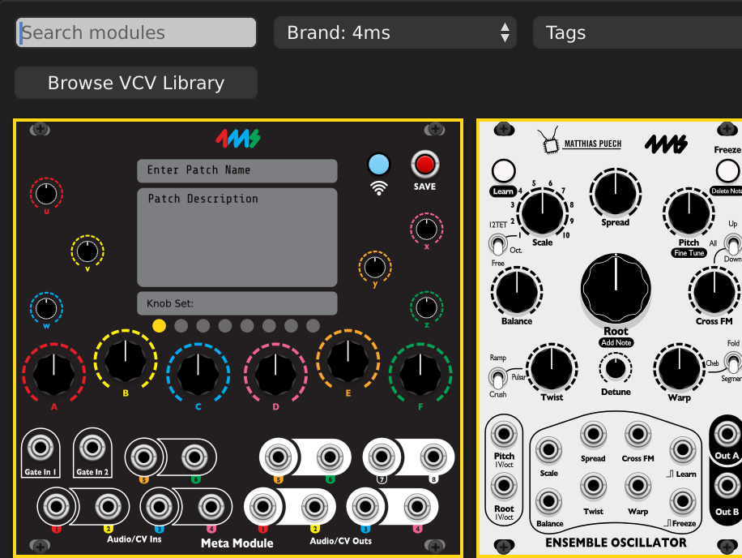](https://metamodule.info/docs/img/vcv-rack-modules.png)

How to install manually

There is normally not any reason to install plugins manually. However, if you were asked by Support to try a special version, or are beta-testing, then [here is the procedure to do a manual installation](https://metamodule.info/docs/rack_manual_install.html).

**Creating patches**

* **1. Create a patch in VCV Rack**

Add modules, patch them together, and set knobs and switches like you would do on a hardware Eurorack system. If you need help using VCV Rack, there are many video tutorials on Youtube. Use the VCV Audio module to listen to your work as you patch.

All modules from 4ms are compatible with the MetaModule, plus about 800 more!

See the [FAQ](https://metamodule.info/docs/faq.html#what-modules-from-vcv-rack-can-i-use-on-the-metamodule) for more information, or browse the complete up-to-date list on the [Plugins page](https://metamodule.info/plugins)

For an example patch, try [SpringsintoCaves](https://metamodule.info/dl/patches/SpringsintoCaves.vcv). Or [browse the example patches](https://metamodule.info/dl/patches/)

[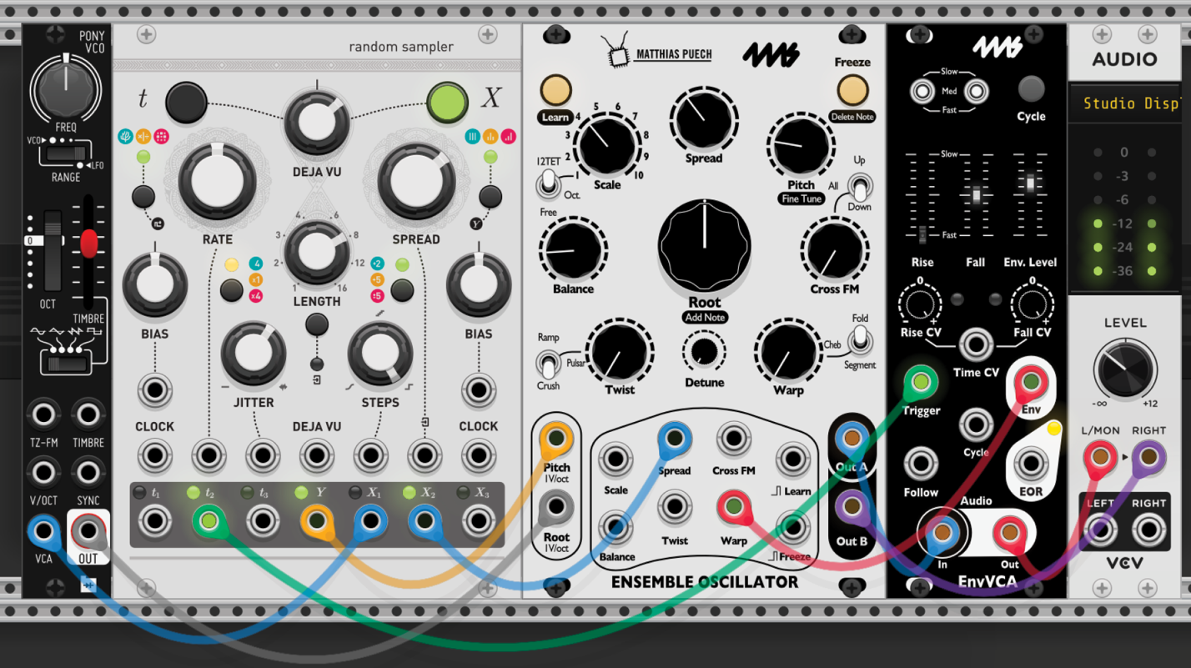](https://metamodule.info/docs/img/vcv-patch-start.png)

* **2. Add the MetaModule**

Right-click (or control-click) on an empty rack space to display the list of modules. Find the MetaModule Hub (search for MetaModule or browse the 4ms brand).

[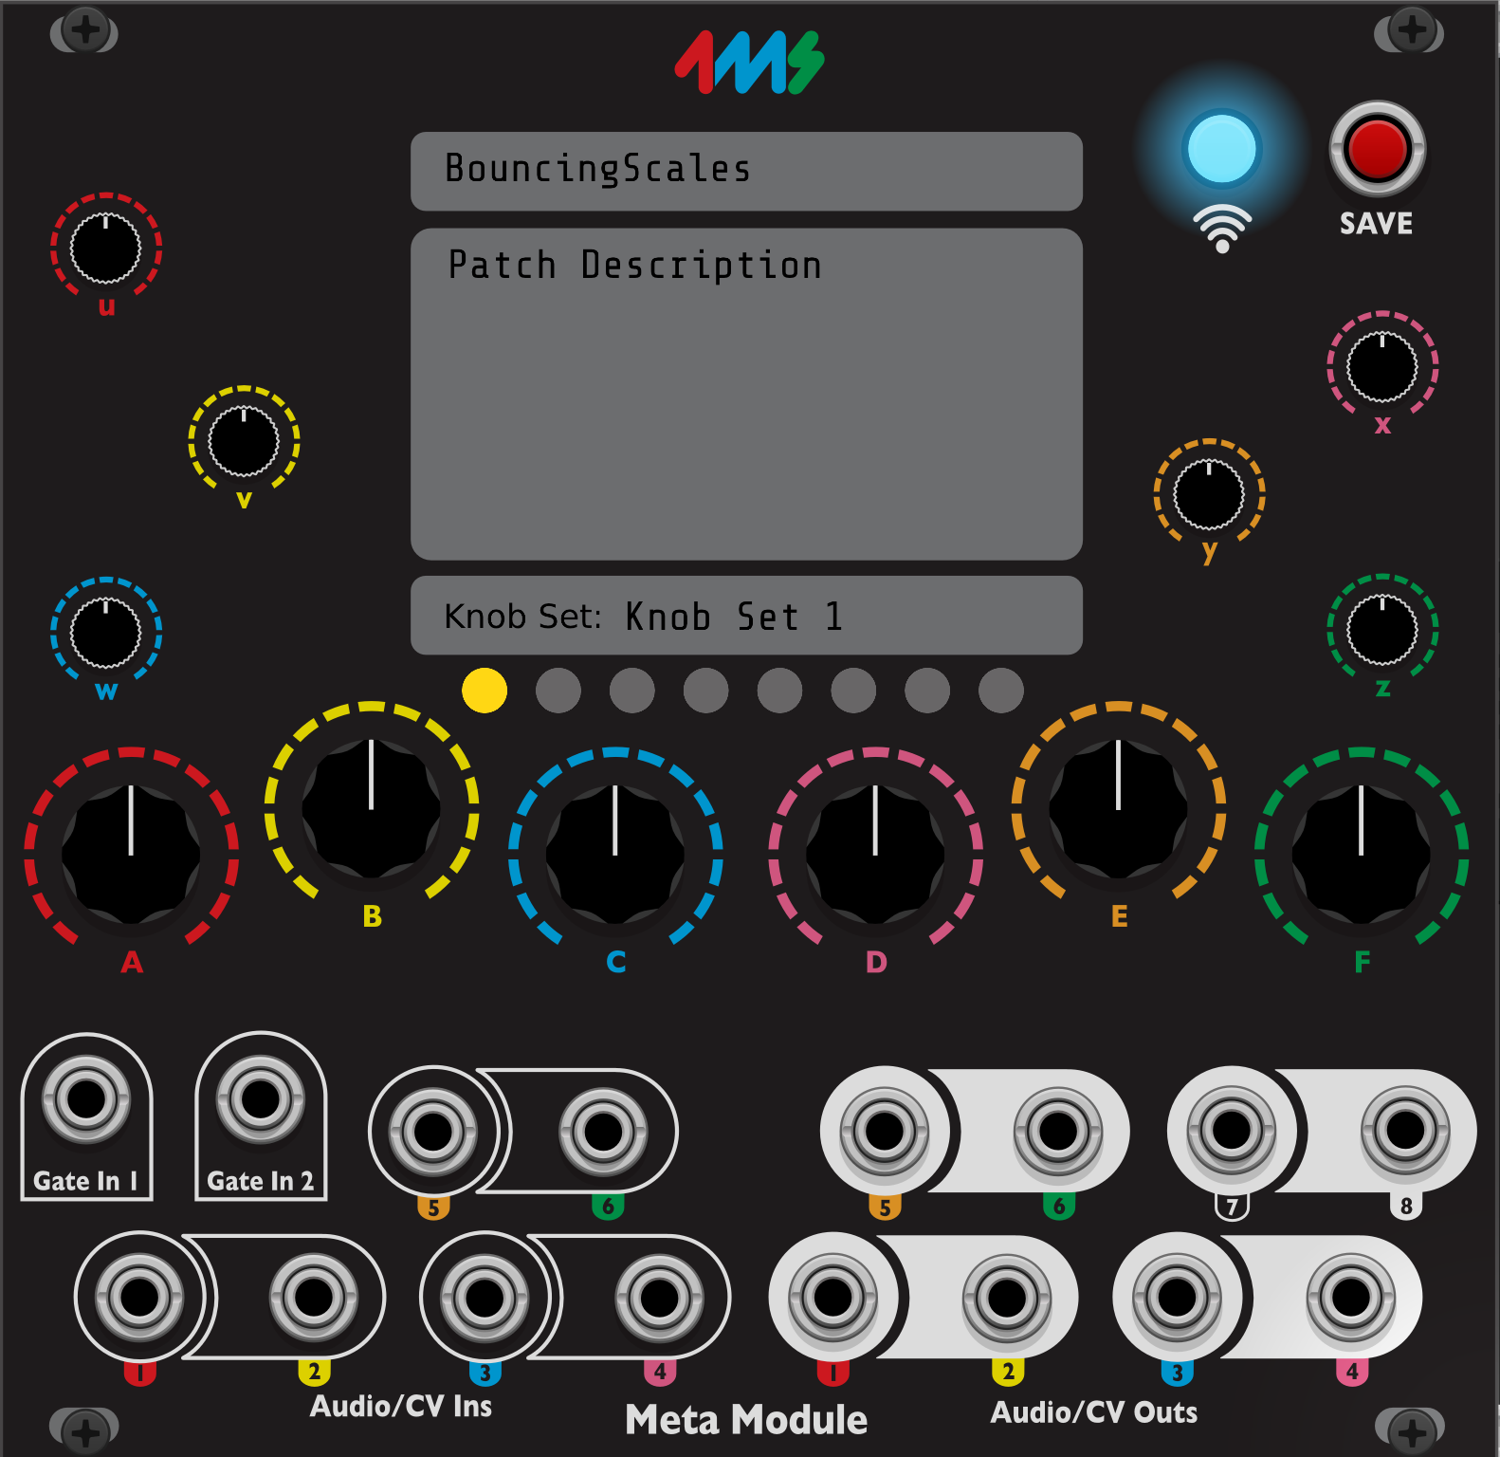](https://metamodule.info/docs/img/vcv-metamodule-hub.png)

* **3. Create Knob Mappings**

First, click the colored ring around any knob on the MetaModule Hub.

Then click on the knob, button, switch, or slider you want to map to.

*Tip: if you're zoomed out, it might be hard to click the colored ring. Shift+click anywhere on the knob itself also works.*

You can map up to 8 virtual knobs to a single MetaModule knob! This is known as a [multi-map](https://metamodule.info/docs/using_metamodule.html#mapping-to-more-than-one-knob-multi-maps)

[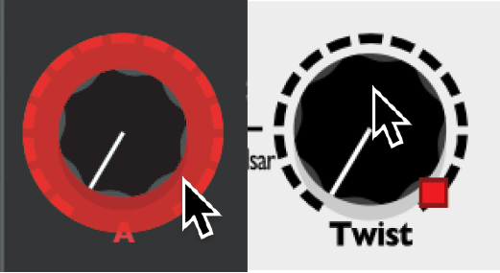](https://metamodule.info/docs/img/vcv-make-mapping.png)

* **4. Create Jack mappings**
  + Jacks can be mapped by patching cables to the MetaModule.

For example, if you want signal on the output jack of a VCA module to come out of the physical MetaModule's Out 1 jack, then drag a cable between those two jacks.

* + If you want to also listen to that output, use two cables (Tip: Cmd+drag on Mac or Ctl+drag on Windows/Linux to create a new cable on top)

*The MetaModule Hub does not send any signals out, or do anything to the signals that you send in. The cables connected to it are just there to tell the MetaModule what you want to have mapped to each jack when you run the patch on the MetaModule.*

[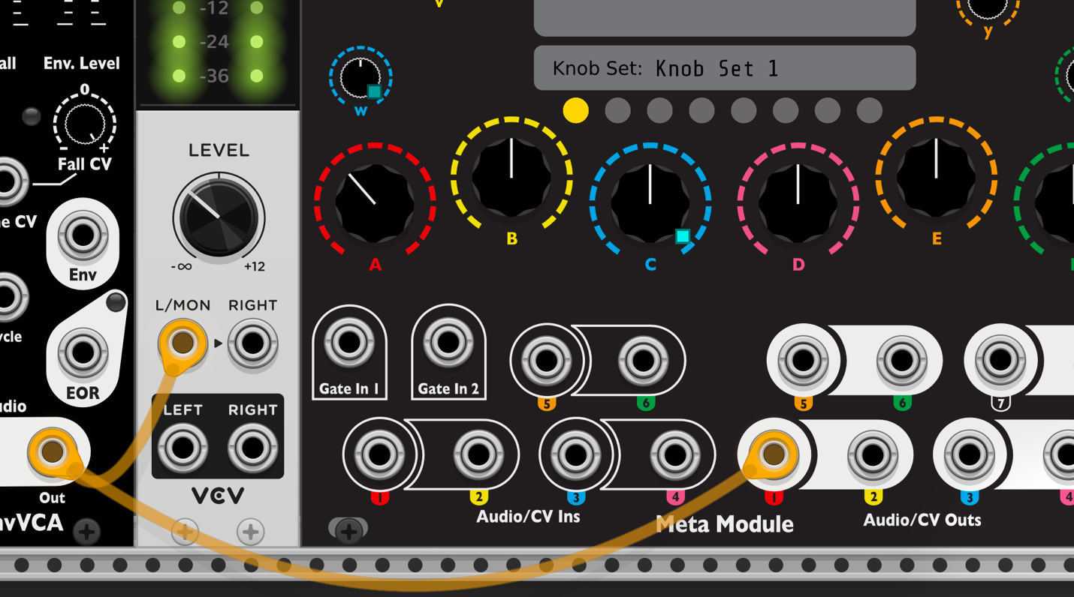](https://metamodule.info/docs/img/vcv-map-outjack.png)

* **Completed Patch:**  
    
  [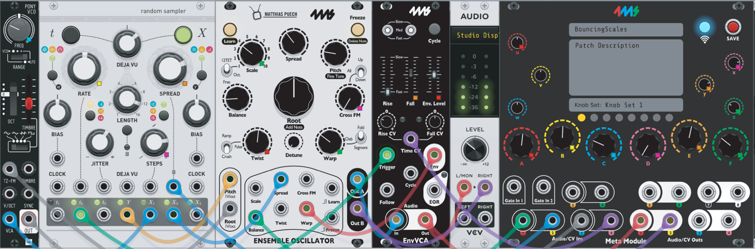](https://metamodule.info/docs/img/vcv-patch-done.png)
* **5. Save the Patch**

Give the patch a name by typing it in the top box.

You can also give it a description or patch notes in the box below.

Click the red SAVE button.

This will create a file with the .ymlextension.

*Note: VCV Rack patch files end in .vcvand cannot be read by the MetaModule.*

Save the file on a USB drive or microSD Card. You can save patches in folders to keep them organized. However, the MetaModule will not find patches in sub-folders of folders.

[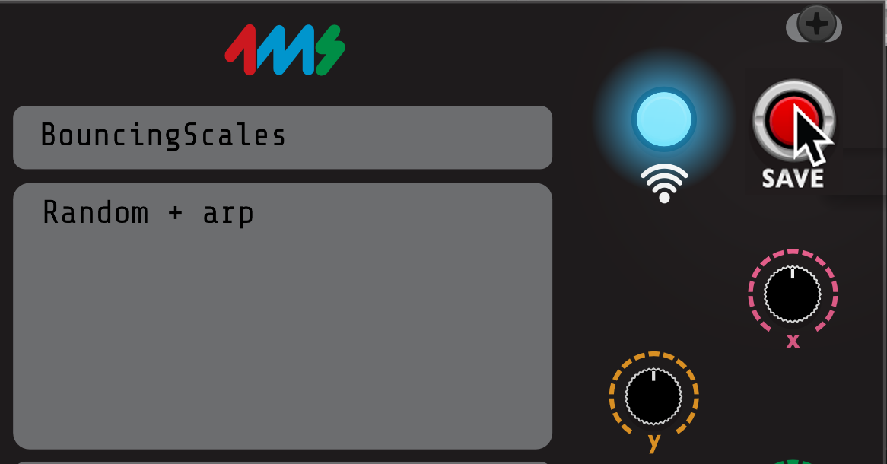](https://metamodule.info/docs/img/vcv-naming-patch.png)

* **6. Load the patch into the MetaModule**
  + Insert the disk into the MetaModule.
  + Go to the Patch Selector page and open your patch.
  + Plug Outs 1 and 2 into your output mixer/speakers/headphone amp.
  + Press the Play icon to start/stop the audio.
  + Enjoy!

[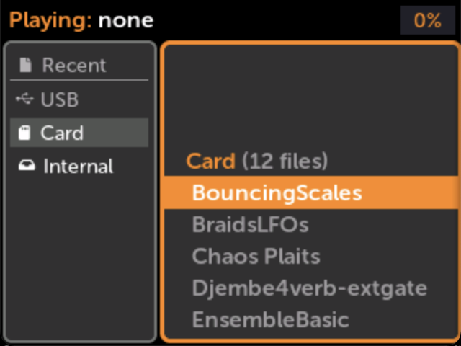](https://metamodule.info/docs/img/vcv-load-bouncingscales.png)  
[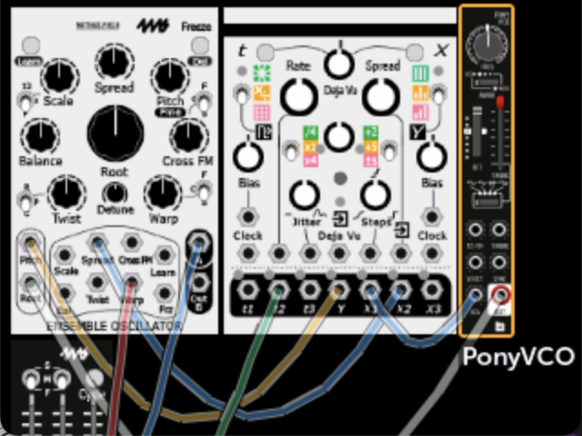](https://metamodule.info/docs/img/vcv-play-bouncingscales.png)

How to set the name or min/max range of a knob mapping

* **Right-click the MetaModule Hub knob**
  + Type in a brief name for the knob mapping if it's helpful for you to remember.
  + Change the Min and Max values if you want to limit the range of the virtual knob. *Tip: If you make Max less than Min, the knob will turn "backwards"*
  + If you have multiple virtual knobs mapped to this knob, then a separate Min and Max slider will be shown for each one.

[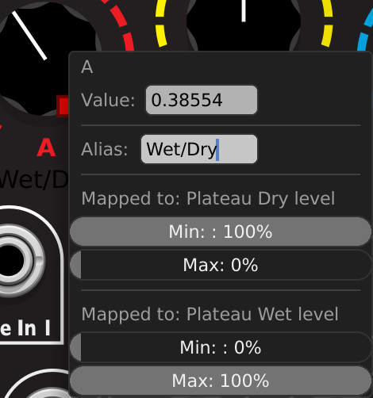](https://metamodule.info/docs/img/vcv-mapping-range.png)

How to remove a knob mapping

* **Right-click the MetaModule Hub knob or the virtual module knob**

Select "Unmap" from the menu.

[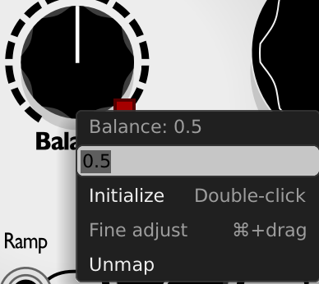](https://metamodule.info/docs/img/vcv-unmap.png)

**Creating Knob Sets in VCV Rack**

A Knob Set is a group of mappings. You can create up to eight Knob Sets in a MetaModule patch and switch between them on the fly when running the patch on the MetaModule.

Knob Sets are a great way to control the entire patch using just the 12 on-board knobs.

See [Knob Sets](https://metamodule.info/docs/using_metamodule.html#knob-sets) for more information.

Selecting a Knob Set

* **Click one of the yellow circles on the MetaModule Hub**

Each circle chooses a Knob Set (1-8).

The knob mappings for the selected Knob Set will be shown in the patch. Creating, editing, and removing knob mappings will change only the current Knob Set.

Mapped knobs won't change their values until you wiggle the MetaModule knobs.

[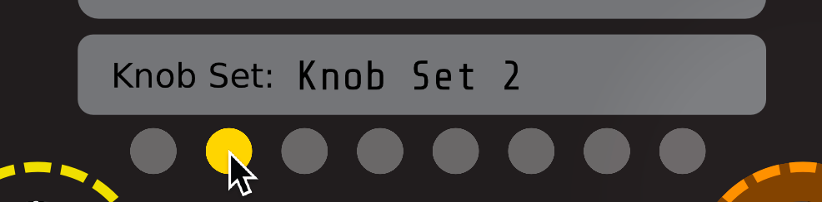](https://metamodule.info/docs/img/vcv-knobset-2.png)

Naming Knob Set

Select a Knob Set and type a name in the box above the yellow circles.

This name will be displayed on the MetaModule.

**MIDI Mapping**

When making patches in VCV Rack, it's usually most convenient to use the VCV MIDI modules to create MIDI mappings. You also can make MIDI Mappings using the MetaModule itself, see [MIDI Input](https://metamodule.info/docs/using_metamodule_jacks.html#midi-input) for details.

How to map MIDI notes, gates, velocity, and aftertouch

VCV Rack and MetaModule support polyphonic MIDI notes, gates, velocity, and aftertouch. There maximum polyphony number is 16, but often you will limit this to 4 - 8 when creating patches for the MetaModule.

In addition to polyphonic note information, you can map pitch wheel, mod wheel, clock, divided clock, re-trigger, start, stop, and continue.

Any of these MIDI signals can be mapped to virtual module jacks simply by connecting cables, however for MIDI signals you don't connect to the MetaModule directly. Instead, you connect to the built-in MIDI and SPLIT modules. The MetaModule recognizes these modules and scans their connections, generating MIDI mappings for your patch. These modules won't display when you load the patch onto the MetaModule, they just are used to tell the MetaModule how you want MIDI to be mapped. Also, these modules are fully functionaly within VCV Rack, so you can test how your patch works with MIDI on VCV Rack before transferring it to the MetaModule.

* **Add the MIDI CV Module to your VCV Rack patch**

[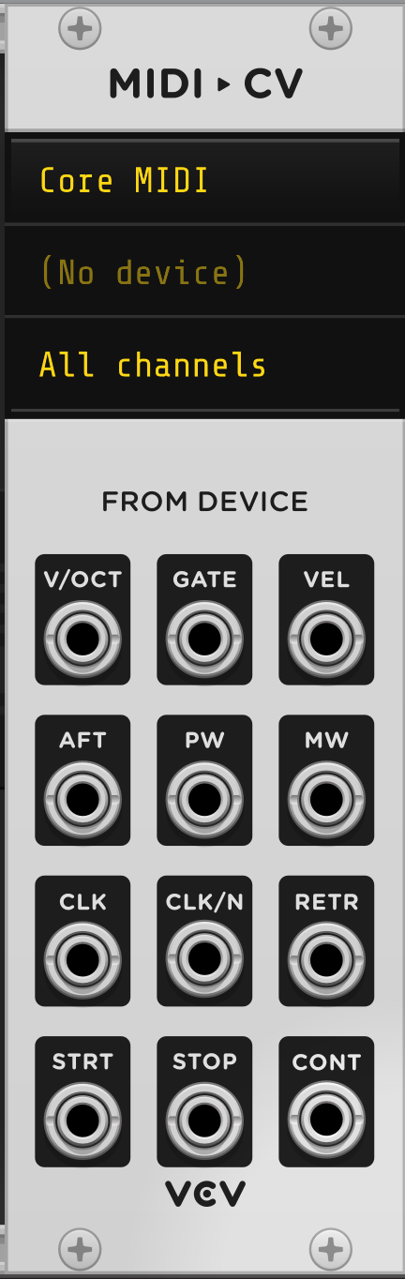](https://metamodule.info/docs/img/vcv-midicv-module.png)

* **Select the number of polyphony channels**

*Polyphony is the maximum number of notes that can be played at once.*

* + Right-click the MIDI-CV module to see the menu.
  + Select the desired number under "Polyphony channels".

[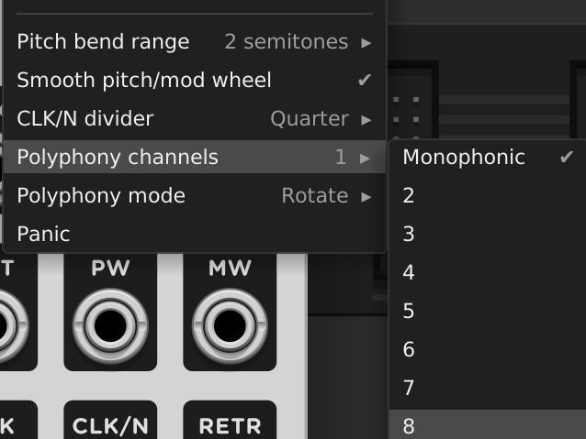](https://metamodule.info/docs/img/vcv-midi-polynum.png)

* **Add a SPLIT module for each polyphonic MIDI parameter you want to map**

MetaModule does not support VCV Rack's polyphonic cables, so you must use the SPLIT module to split the signal into monophonic cables.

You can verify the polyphony number you chose earlier: it will display on the SPLIT screen.

[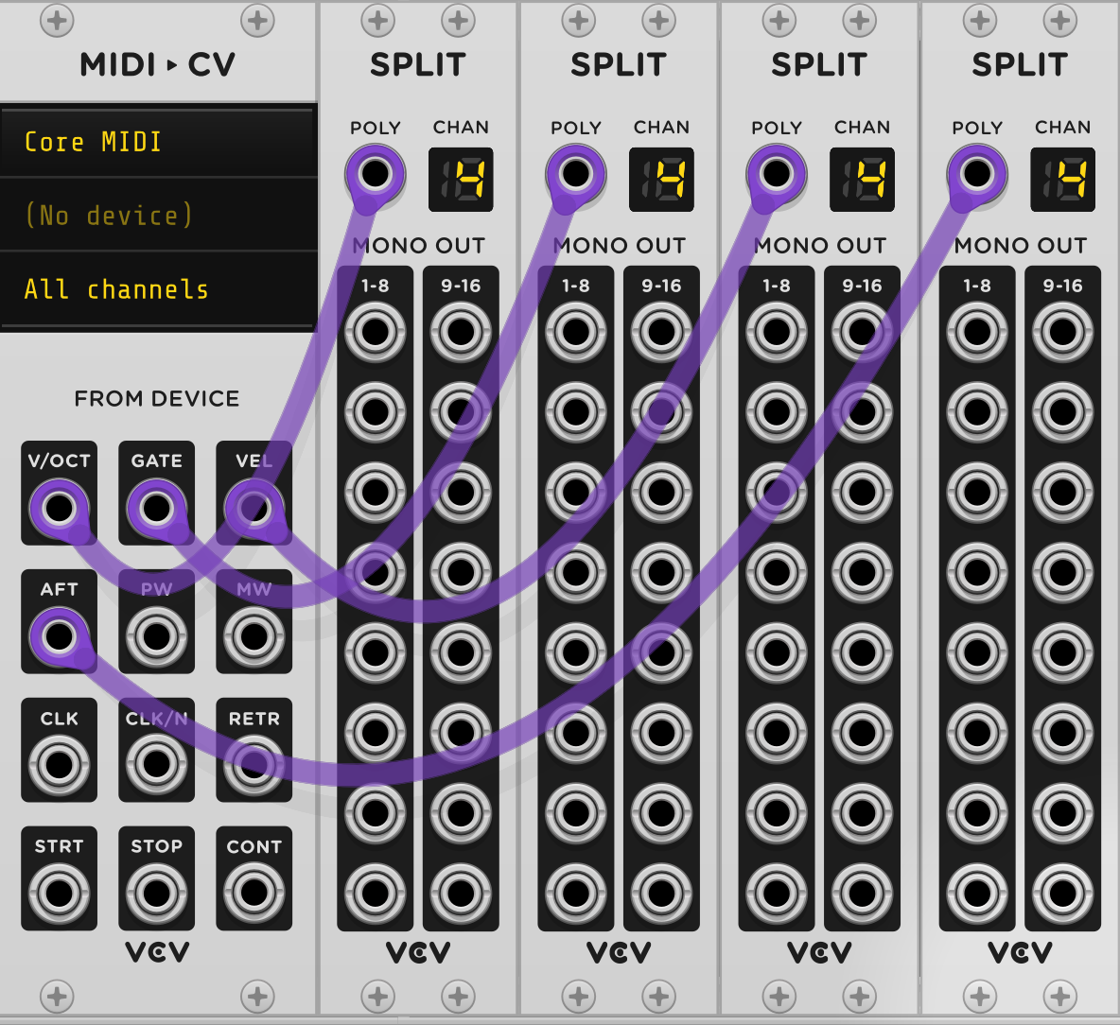](https://metamodule.info/docs/img/vcv-midi-split-4.png)

* **Create cables from the SPLIT modules to your modules**

Connect to whatever jacks you want to be MIDI mapped.

Finish your patch normally (e.g., mix the outputs and connect the mixer output to the MetaModule)

[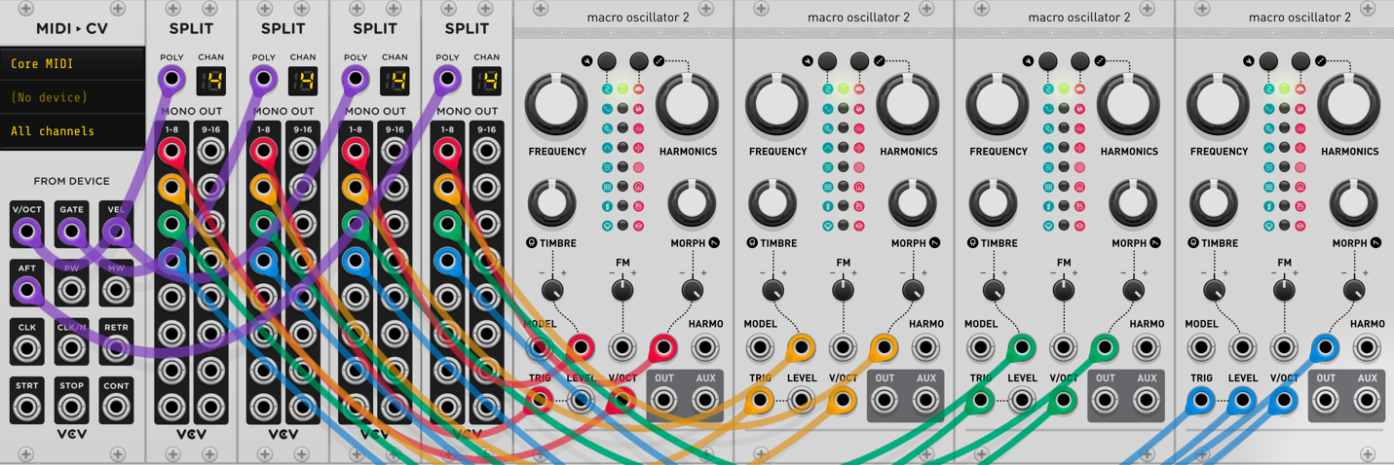](https://metamodule.info/docs/img/vcv-midi-mapped-4.png)

* **Finish the patch**

Finish your patch normally (e.g., mix the outputs and connect the mixer output to the MetaModule)

Create knob mappings from the MetaModule. Multi-maps are often useful with polyphonic patches (shown in the image).

[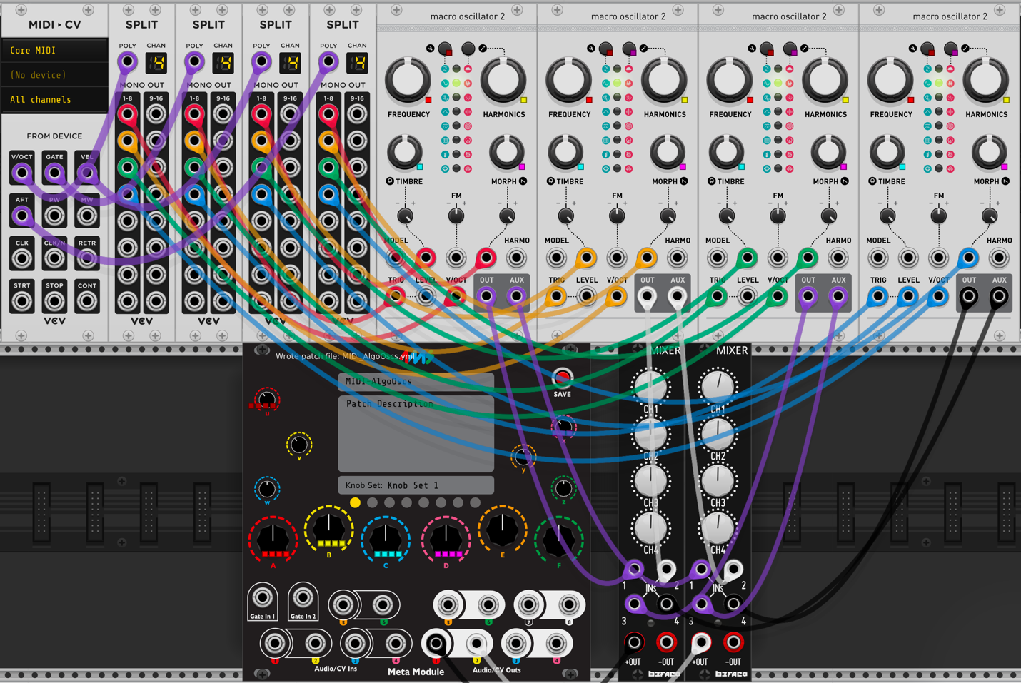](https://metamodule.info/docs/img/vcv-midi-4-done.png)

How to map other MIDI signals

The procedure is identical to the above procedure, but since these are not polyphonic signals, you don't need to use a SPLIT module. Just patch directly from the MIDI module to the jacks you want mapped.

* You can map Pitch Wheel, Mod Wheel, Clock, Divided Clock, Re-trigger, Start, Stop, and Continue using the MIDI-CV module.

[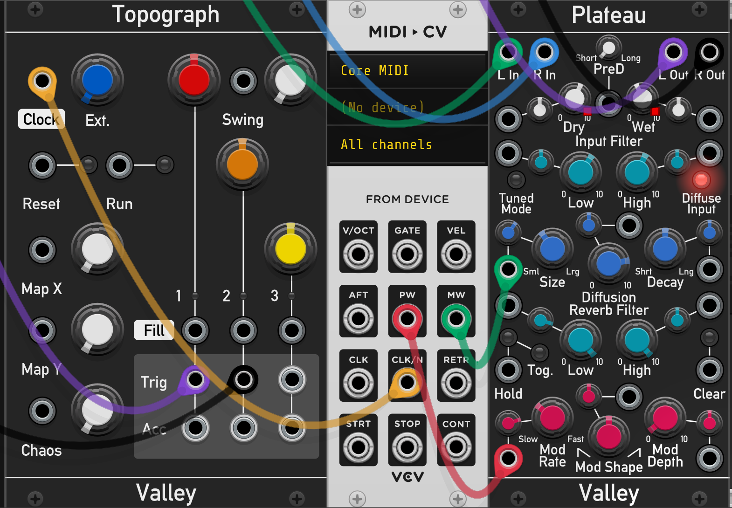](https://metamodule.info/docs/img/vcv-midi-other-map.png)

* You can map MIDI notes to gates by using the MIDI-Gate module.

Map MIDI CC signals to jacks using the MIDI-CC-CV module.

[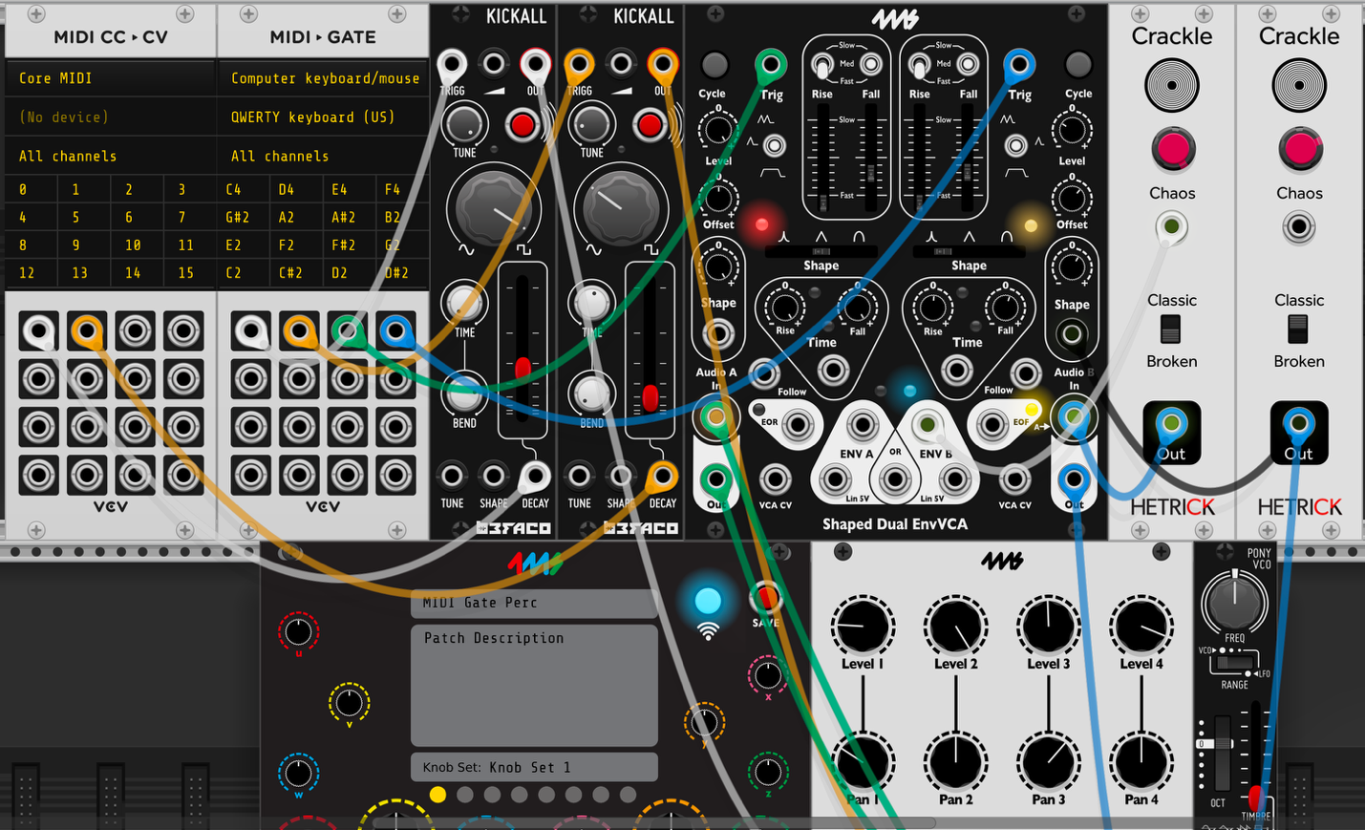](https://metamodule.info/docs/img/vcv-midi-gate-map.png)

* You can map MIDI CCs to knobs using the MIDI-CC module.

Click on an empty line on the MIDI-CC module, and send a MIDI CC event. Then click on a knob to create the mapping.

Notice that VCV Rack indicates a MIDI mapping with a yellow square. This should not be confused with the yellow square used by Knob B of the MetaModule. If in doubt, hover the mouse over the Knob B ring, and if the other knob's square flashes rapidly then it's mapped the MetaModule.

[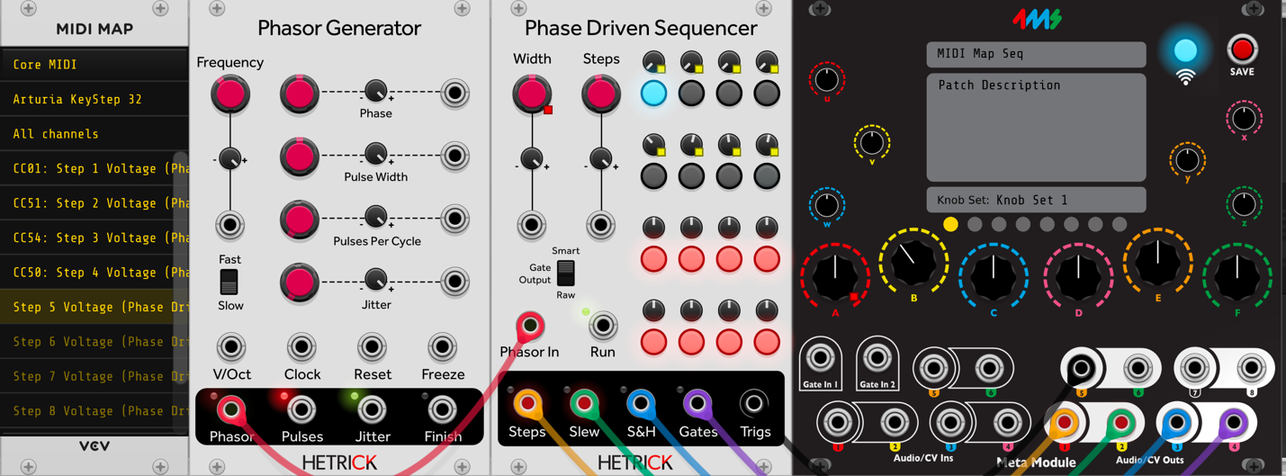](https://metamodule.info/docs/img/vcv-midi-knob-map.png)

**Tip: Favorite the MetaModule-compatible modules:**

If you have trouble remembering which modules can be run on the MetaModule, one way to keep track of this is to mark all compatible modules as "Favorite" in VCV Rack.

User tenofswords created a python script to do this automatically for you: [4ms-MetaModule-Scripts](https://github.com/gregornoriskin/4MS-MetaModule-Scripts)

Running this requires some basic knowledge of using python scripts. Some discussion is here:[MetaModule Forum: MetaModule Tag in Rack to Identify Supported Modules](https://forum.4ms.info/t/metamodule-tag-in-rack-to-identify-supported-modules/69/32)

**Plugins**

**Installing Plugins**

* **1. Download plugins to a USB drive or microSD card**

Use the [Plugins](https://metamodule.info/plugins) link above.

Save each .mmplugin file to the USB or microSD card. You can put them in the root directory, or in a folder called metamodule-plugins

Insert the drive into the MetaModule

[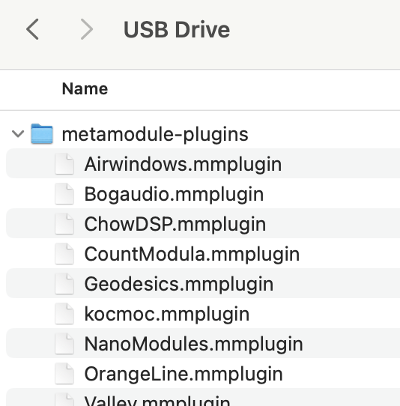](https://metamodule.info/docs/img/macos-plugins-disk.png)

* **2. Click Settings in the Main Menu**

[](https://metamodule.info/docs/img/main-menu-settings.png)

* **3. Click Plugins**

[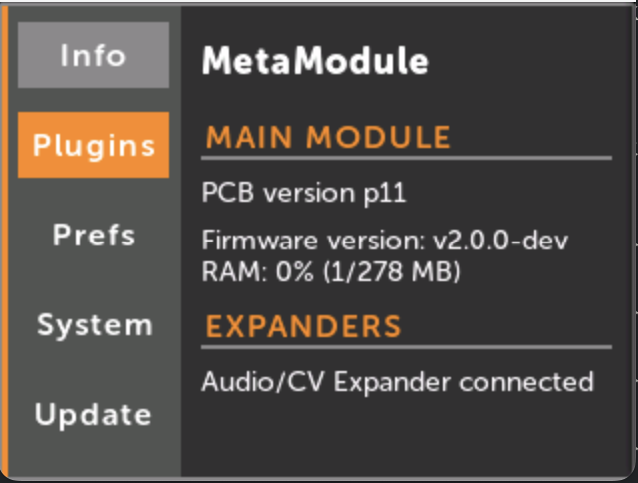](https://metamodule.info/docs/img/settings-plugins.png)

* **4. Click Scan disks**

[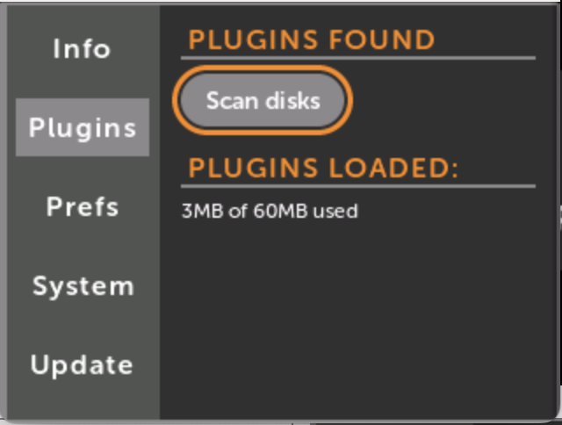](https://metamodule.info/docs/img/scan-plugins.png)

* **5. Click a plugin to load it**

The plugin will stay loaded until you unload it or reboot.

[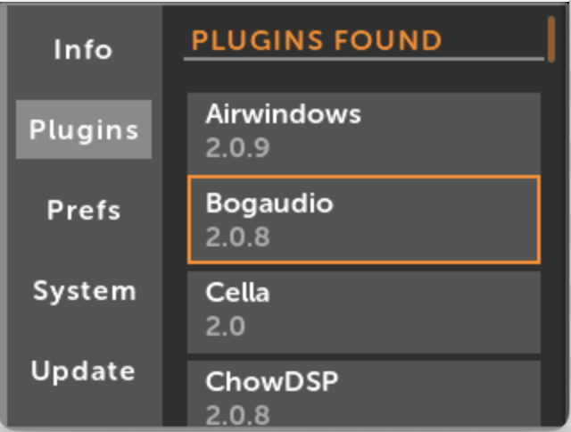](https://metamodule.info/docs/img/plugins-found.png)

* **Or, load all plugins**

Scroll to the bottom and click the Load All button to load all plugins found

[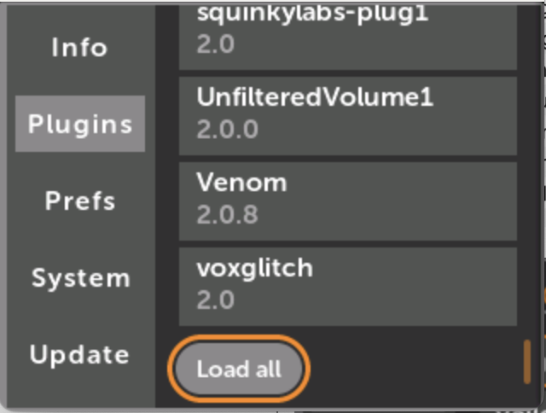](https://metamodule.info/docs/img/plugins-load-all.png)

**Pre-loading Plugins**

If you want a plugin to load automatically when you power on, you can tell the MetaModule to pre-load it.

A USB drive or microSD card containing the plugin file must be installed in the MetaModule when you power on for this feature to work. If not, you can load the plugin normally after startup.

* **1. Click a plugin name under PLUGINS LOADED**

If the plugin is not yet loaded, then follow the [instructions above](https://metamodule.info/docs/plugins.html#installing-plugins).

[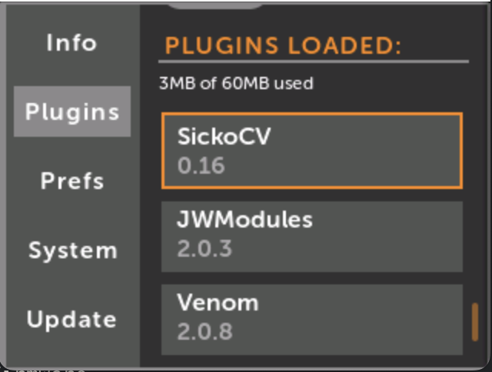](https://metamodule.info/docs/img/plugins-loaded.png)

* **2. Enable Pre-load**

The pre-load status of a plugin is saved when you exit the Plugins tab. The next time you power on, the MetaModule will search the USB drive and microSD card for a plugin with a matching name.

Note: The wrong version may get loaded if you have different versions of the same plugin on an microSD card and a USB Drive, or different versions in the metamodule-plugins/ folder and in the root directory.

[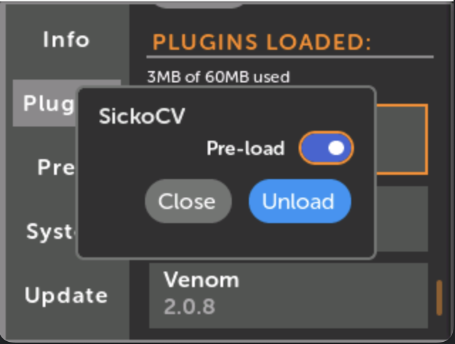](https://metamodule.info/docs/img/plugins-preload.png)

* **Or, Pre-load all the currently loaded plugins**

Click Pre-load Current at the bottom of the list of loaded plugins.

The next time you power-on, the MetaModule will pre-load only the current set of loaded plugins.

[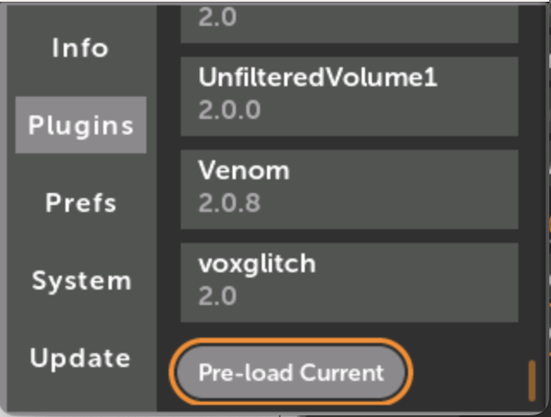](https://metamodule.info/docs/img/plugins-preload-current.png)

**Viewing the modules in a plugin**

* **1. Click New Patch from the Main Menu**

To add a module to an existing patch, click the + icon in the top button bar.

[](https://metamodule.info/docs/img/main-menu-new.png)

* **2. Click the name of the plugin, then browse the modules**

Click once on any module to view it full-screen.

Click a second time to add it to the current patch.

[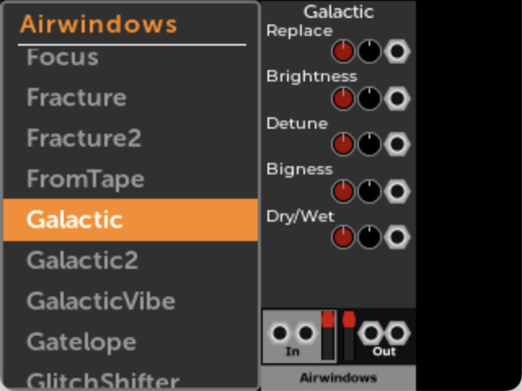](https://metamodule.info/docs/img/airwindows-module-list.png)

**Module Action Menu**

The Module Action Menu is found by clicking on a module in a patch and then clicking on the Tool icon at the top.

* [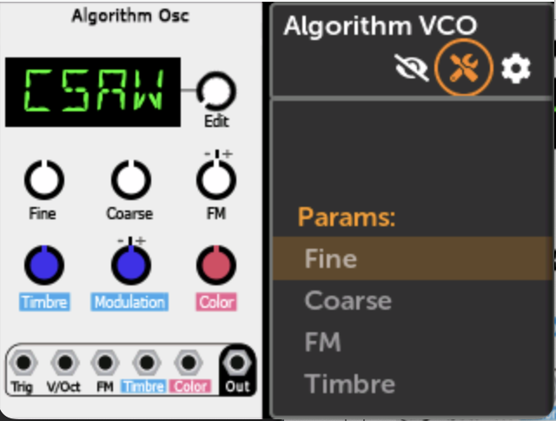](https://metamodule.info/docs/img/module-action-icon.png)
* [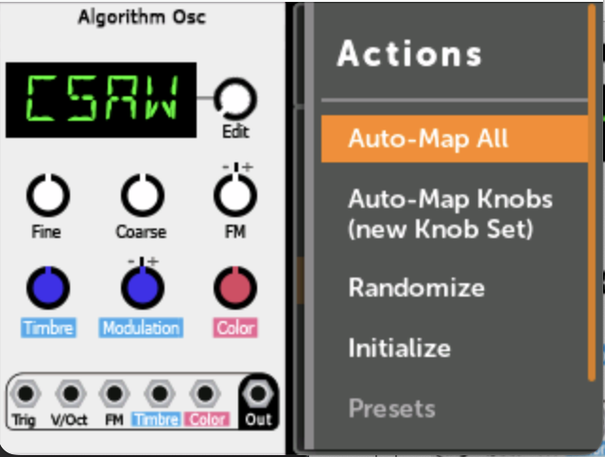](https://metamodule.info/docs/img/module-action-menu.png)

**Actions**

Auto-map All

This action attempts to maps all knobs and jacks in the order that they appear in the module. Existing maps will be preserved, and new Knob Sets will be created if needed.

Jacks will be mapped to In 1-6 and Out 1-8, skipping any jacks that are already mapped.

Auto-map All is a great way to try out a module or quickly create a single-module patch.

Since this action will often fill all your jack mappings, it's recommended to use Auto-map knobs (new Knob Set) for multi-module patches.

Auto-map knobs (new Knob Set)

Similar to Auto-map All, but this will create a new Knob Set and only map the knobs (not jacks). The new Knob Set will be given the name of the module (e.g. "EnOsc" or "Plateau").

If there are more than 12 controls, then only the first 12 will be mapped.

Randomize

This randomizes the value of all parameters. Note that in VCV Rack, modules can exclude particular parameters from being randomized. This is not present in MetaModule, but will be added in a future update.

Initialize

This initializes or resets the module. Different modules may interpret this differently, but typically this sets all knobs, switches, etc to their basic states.

This action does not remove any mappings or cables, but otherwise resets the module to the same state it was in when you first added it to the patch.

Presets

Clicking this will let you browse all factory presets for the module. If no presets are found, then this option will be disabled.

Note that in the current MetaModule firmware, loading user-created presets is not supported. Users who are familiar with the command line could add a preset to a plugin file like this:

tar -xf PluginName.mmplugin

cp 01_my_preset.vcvm PluginName/presets/ModuleName/

tar -cf PluginName.mmplugin PluginName/

Delete

Delete the module from the patch, removing all cables and mappings. This cannot be undone. (However, you can Revert the patch file it to restore the module).

**Patch/Module Settings**

**Module and Patch Display Settings**

The Patch View page and Module View page each have their own display settings menu. These menus control how mappings and cables are drawn when viewing modules and their connections.

* **Patch View display settings**

The Patch View display settings menu is found by clicking on the gear icon when viewing a patch.

[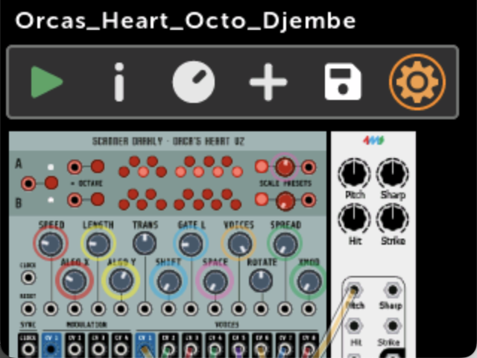](https://metamodule.info/docs/img/patch-view-gear-icon.png)

* [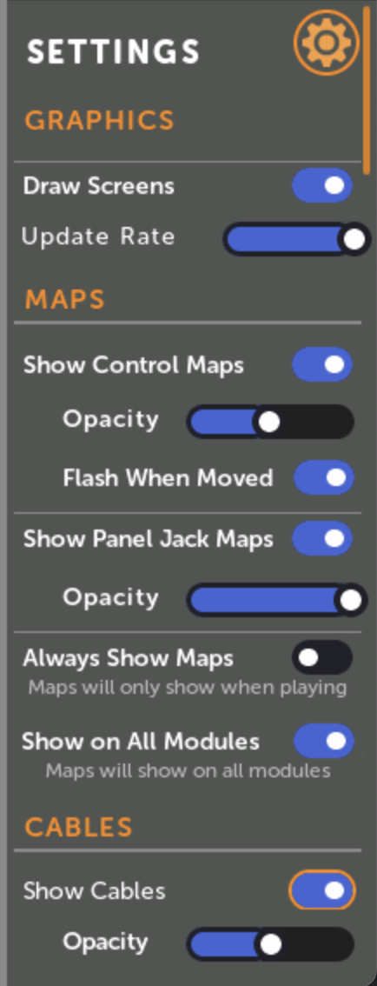](https://metamodule.info/docs/img/patchview-settings.png)
* **Module View display settings:**

The Module View display settings menu is found by clicking on a module in a patch and then clicking on the gear icon at the top.

[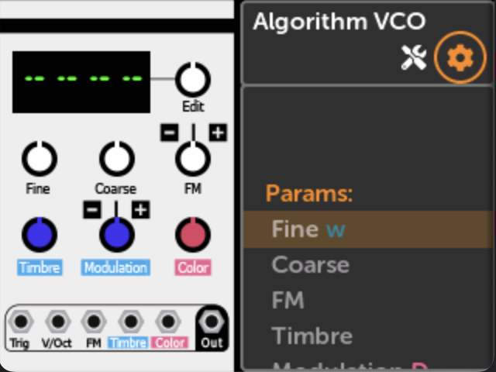](https://metamodule.info/docs/img/mv-settings-icon.png)

* [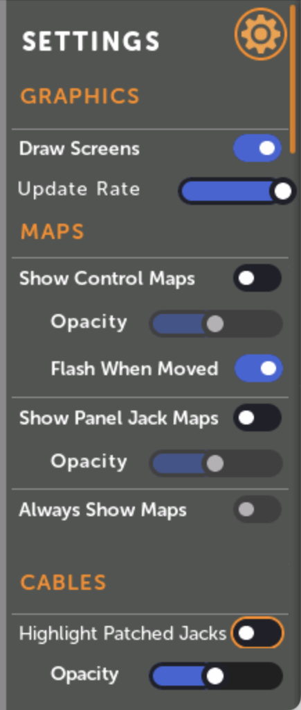](https://metamodule.info/docs/img/mv-settings-all.png)

Graphics

These options control how graphic screens on modules are displayed. The term "graphic screen" is a loose term that refers to any element on the module that's drawn dynamically (besides knobs, sliders, buttons, switches, lights, and text displays). This may refer to anything from waveform or BPM displays, to static portions of the faceplate that the module designer chose to draw with vector commands, to text under knobs that may change in different modes.

* **Draw Screens**: toggles whether to draw graphic screens on modules. If you have issues with the module responding slowly to the rotary encoder and Back button, then try disabling screens or adjusting the Update Rate.
* **Update Rate**: When screens are enabled, you can throttle the frame rate with this option. When set to the maximum value (fully to the right), each graphic screen in the patch will be updated in turn, one graphic screen per 60Hz refresh. Each click of the slider to the left updates screens half as often (i.e. one screen per 30Hz refresh, then 15Hz refresh, etc..)

Maps

These options set how control mappings (knob, switch, and button maps) are displayed:

* **Show Control Maps**: toggles whether to hide or show a colored ring around controls that are mapped. The color corresponds to the panel knob it's mapped to.
* **Opacity**: How opaque or transparent to draw the colored rings.
* **Flash When Moved**: Whether to flash the colored ring when its panel knob is moved. This can be turned on even if Show Control Maps is off.

These options set how jack mappings to the panel are displayed:

* **Show Panel Jack Maps**: toggles whether to hide or show a colored circle on jacks that are mapped to the panel. The color corresponds to the panel jack it's mapped to.
* **Opacity**: How opaque or transparent to draw the circles. If Opacity is more than about 40%, the number of the jack will be drawn inside the circle.

This option refers to both control mappings and jack mappings:

* **Always Show Maps**: Enabling this option will hide control and jack maps when you are viewing a patch while a different patch is playing (or paused). This option is disabled if both Show Control Maps and Show Panel Jack Maps are off.
* **Show on All Modules**: (Patch View only) When this option is enabled, maps will be drawn on all modules in the patch. When this is disabled, maps will be drawn on only the module that's currently focussed. This option is disabled if both Show Control Maps and Show Panel Jack Maps are off.

Cables

* **Show Cables**: (Patch View only) Toggles whether to draw cables connecting modules.
* **Highlight Patched Jacks**: (Module View only) Toggles whether to draw a colored square on jacks that have an internal cable patched to them. Output jacks have a square drawn around the outside of the jack, and input jacks have a square drawn on the inside of the jack. The color of the square matches the color of the cable as seen in the patch view.
* **Opacity**: How opaque or transparent to draw the cables or squares.

**Patch Name and Description**

* **Patch Description**

The Patch Description page is opened by clicking the (I) info icon when viewing a patch.

* [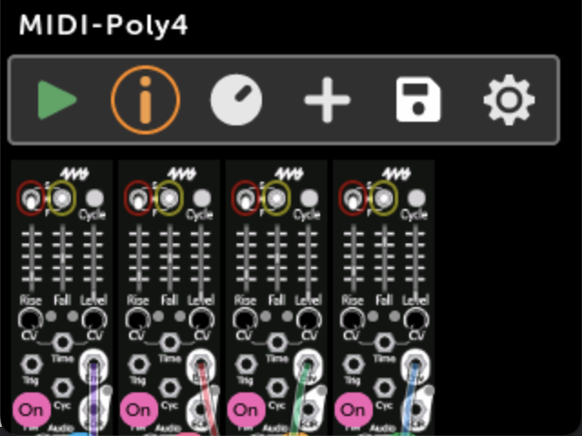](https://metamodule.info/docs/img/patchview-info-icon.png)
* The patch name, file name, description, MIDI polyphony channels (if MIDI notes are mapped) are shown.
* [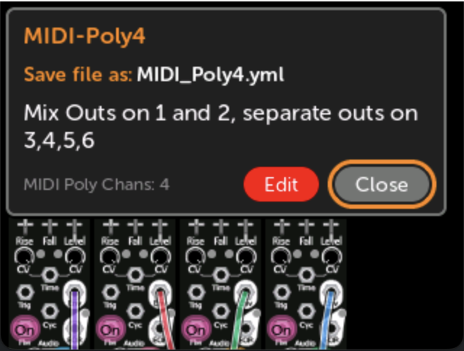](https://metamodule.info/docs/img/patch-description.png)
* Click Edit to edit the description.
* [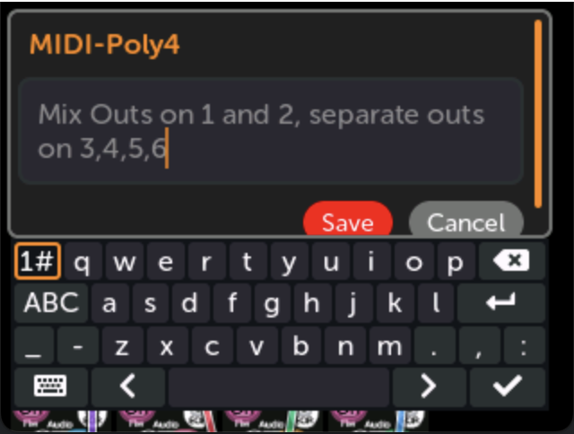](https://metamodule.info/docs/img/patch-description-edit.png)

**Patch File Menu**

* **Patch File Menu**

The Patch File Menu is opened by clicking the file/disk icon when viewing a patch.

While focused on the file icon the file path will be shown.

* [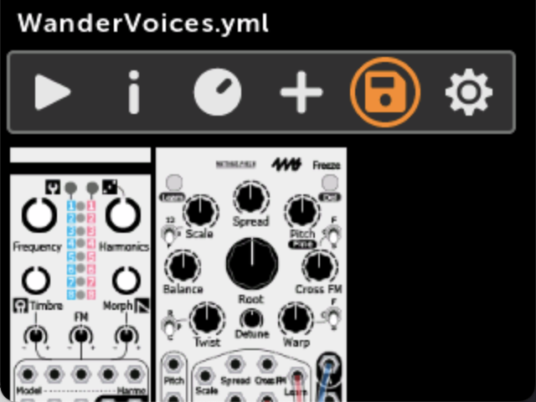](https://metamodule.info/docs/img/patch-view-file-icon.png)
* Save, Duplicate, Move/Rename, Reload (or Revert), Delete
* [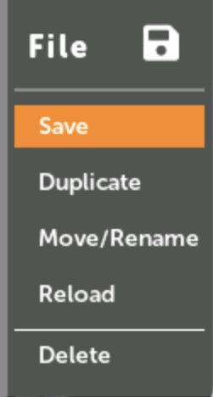](https://metamodule.info/docs/img/file-menu.png)
* **Save**: save the patch file

This will save the current state of the patch including the position of all knobs, switches, and buttons. All mappings will be saved.

If you ejected the disk, then the patch will not save (an error will be shown). In this case, either re-insert the disk and click Save again, or click Duplicate to save in a different location.

* **Duplicate**: save a copy of the patch

Clicking this will bring up a window where you can change the patch name and/or disk or sub-folder.

The new patch file will be opened after the old one is duplicated, but if the old one was playing, it will still be playing.

* [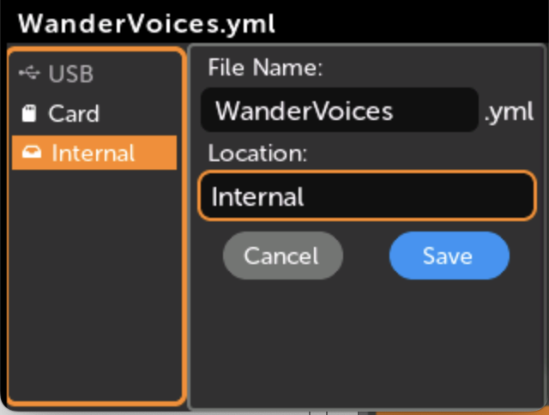](https://metamodule.info/docs/img/duplicate-file.png)
* **Revert** (or **Reload**): Revert all changes to the patch file

This will reload the patch file from disk, losing all changes. It cannot be undone.

If you ejected the disk that the patch file lives on, then the patch cannot be reverted since the original file cannot be loaded.

This option will appear as "Reload" when you have not made any modifications to the patch, and "Revert" when you have modified the patch. The resulting action is the same (reloading the file from disk).

* **Delete**: Delete the patch file

This will delete the patch file from disk. It cannot be undone.

If you ejected the disk that the patch file lives on, then the patch cannot be reverted since the original file cannot be loaded.

**Wi-Fi Expander**

**Getting Setup**

Read the PDF version here: [Wifi Quick Start](https://4mscompany.com/media/MetaModule/Wifi-QSG.pdf)

Connect to MetaModule

1. Power off your system.
2. Connect one end of the included 8-pin cable to the header labelled "WiFi" on the MetaModule, and the other end to the 8-pin header on the Wi-Fi Expander.
3. Make sure the red stripe is up on both ends of the cable.
4. Connect the included 10-pin power cable to Eurorack power with the red stripe down.
5. Power on your case. The Wi-Fi Expander button will turn light blue.

Connecting to a Wi-Fi network (Provisioning)

* **1. Download the ESP BLE Provisioning app on a phone or tablet**
  + iOS: [App Store](https://apps.apple.com/us/app/esp-ble-provisioning/id1473590141)
  + Android: [Google Play Store](https://play.google.com/store/apps/details?id=com.espressif.provble&hl=en_US)



* **2. Open to ESP BLE Provisioning app**

At some point the app will ask for permission to use the camera and/or Bluetooth. Click "OK" or "Allow".

If you do not allow access to the camera and Bluetooth, then you MUST go to your iOS or Android Settings and allow access.

* **3. Tap the gear icon (upper-left) on iOS or the three dots (upper-right) on Android**

This will open the settings page.



* **4. Turn off Encrypted Communication**

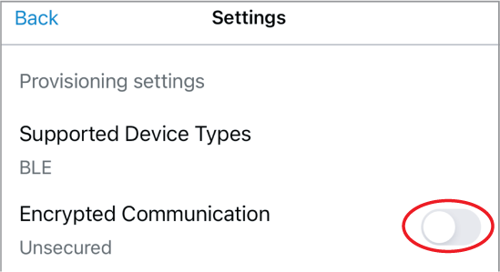

* **5. Tap "Provision Device"**



* **6. Tap "I don't have a QR code"**



* **7. In the PREFIX box, remove the text “PROV_” (if present), and type “4MS”**

On Android, tap “Change” first.

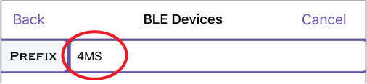

* **8. Tap the Refresh icon or “Scan Again”**

Then tap the 4MS device that appears

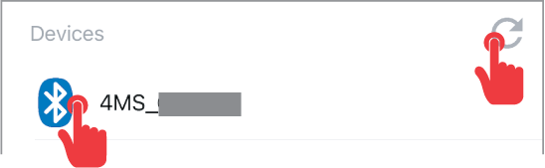

* **9. Select your Wi-Fi network from the list**

Enter your Wi-Fi password when asked.

After a moment, the light on the Wi-Fi Expander will turn green.

* **10. On the MetaModule, go to Settings > Info**

Look for the Wi-Fi IP address

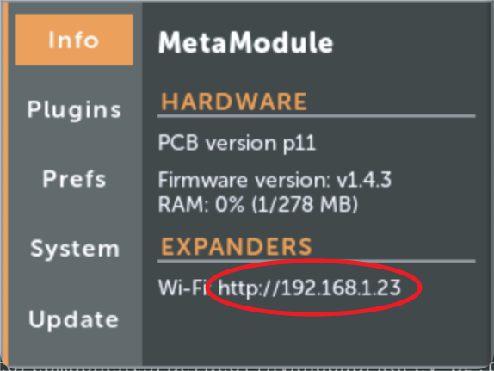

* **11. On your computer, open a browser window and type in the IP address**

Hint: the IP address starts with http://, not with https://

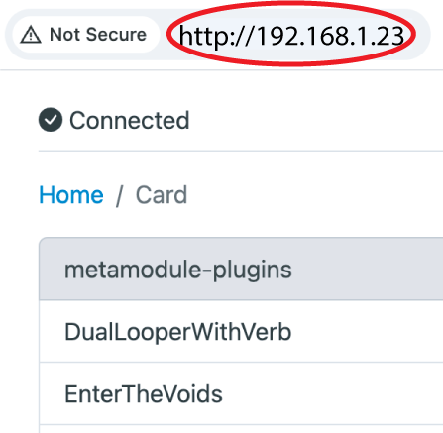

* **You're connected!**

In the browser, navigate to the drive (and optionally, a subfolder) where you want to put a patch.

Click the Upload button and select a .yml patch file to transfer, or drag and drop it.

When the progress bar is complete, the patch file can be played on your MetaModule!

[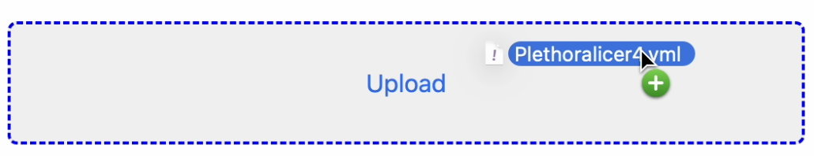](https://metamodule.info/docs/img/browser-drag-drop.png)

After connecting to a Wi-Fi network, you can choose to delete the ESP BLE Provisioning app. However, if you anticipate needing to change Wi-Fi networks, you may want to leave it installed.

**Using the Wi-Fi Expander with VCV Rack**

* **1. Install the 4ms plugin for VCV Rack, version 2.0.9 or later**

Update or install from the [VCV Rack Library](https://library.vcvrack.com/4msCompany)

* **2. Enter the Wi-Fi Expander's address into the VCV Rack MetaModule hub**

Right-click on the MetaModule panel.

From the menu, select "Set Wi-Fi Expander address".

Enter the address you found by going to Settings > Info on the MetaModule (see above).

[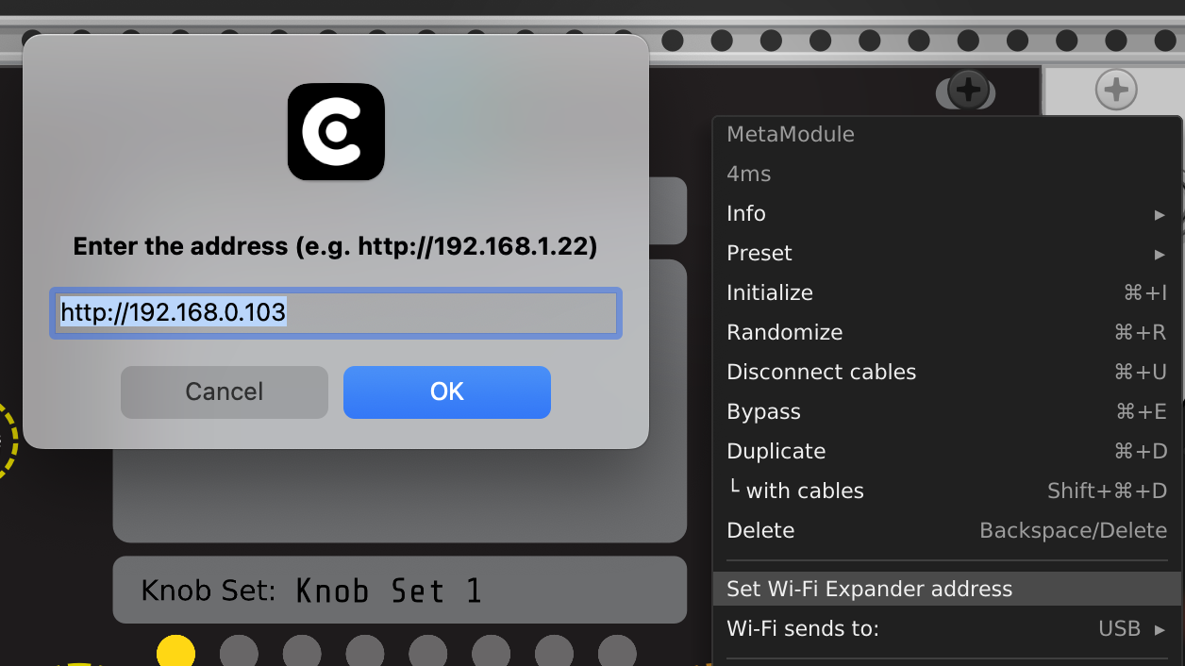](https://metamodule.info/docs/img/vcv-wifi-url.png)

* **3. Select the volume you want to transfer to**

Right-click on the MetaModule in VCV Rack and choose a volume from the "Wi-Fi sends to:" submenu.

Note that the Internal drive has very limited space (2MB max), so it's recommended to store patches on USB or Card if possible.

Note: sending to sub-folders is not yet supported. Use a web browser if you need to do that.

[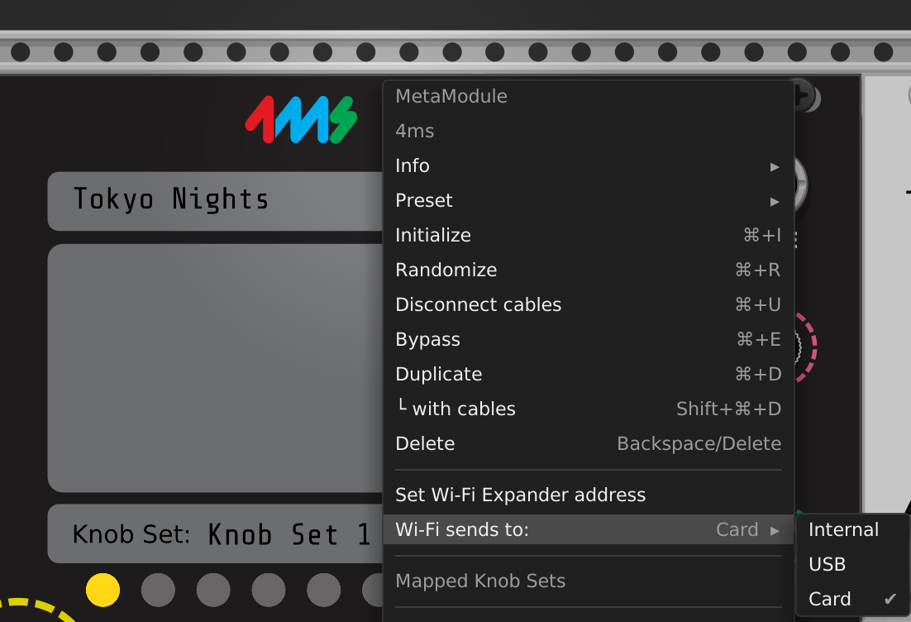](https://metamodule.info/docs/img/vcv-wifi-vol.png)

* **4. Click the Wi-Fi button to transfer a patch**

If you hover the cursor over the button, the Wi-Fi settings will display in the main text box.

After clicking, the top text box will display "Sent patch file" or "Failed to send patch".

[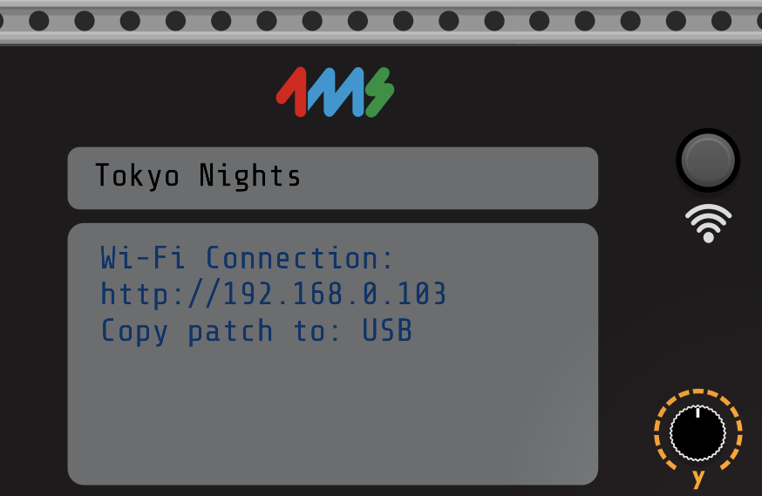](https://metamodule.info/docs/img/vcv-wifi-button.png)

**Changing Wi-Fi networks or Resetting the Wi-Fi Expander**

Power on with the button held down. Release it when it turns red. The light will turn off and then turn light blue. You can then perform the [steps at the top of this page](https://metamodule.info/docs/wifi.html#connecting-to-a-wi-fi-network-provisioning).

**Light Colors**

The Wi-Fi Expander shows its status with a colored button light:

* Red: The Expander has not been told what Wi-Fi network to connect to, or there is an internal error. Reset the Wi-Fi Expander (see above section).
* Light Blue: The Expander cannot find the Wi-Fi network. Check if other devices can see the network, and that the signal strength is high where the Wi-Fi Expander is mounted. Make sure there is a clear line-of-sight from the Wi-Fi Expander to the Wi-Fi router.
* Green: The Expander is connected to a Wi-Fi network.

**Updating Wi-Fi Expander Firmware**

The Wi-Fi Expander firmware will be updated whenever you update the MetaModule firmware and a Wi-Fi Expander is connected via the 8-pin cable.

All MetaModule firmware releases starting with v1.4 contain the Wi-Fi Expander firmware. If you do not have the Wi-Fi Expander connected when you update the MetaModule firmware, then the updater will skip the Wi-Fi Expander updates and just update the MetaModule.

**Wi-Fi Expander Troubleshooting**

* **Cannot get the ESP BLE Provisioning app to see the Wi-Fi Expander module**
  + Did you disable Secure Communication in the app settings?
  + Did you erase the prefix text "PROV" and replace it with "4MS"?
  + Did you give the app permission to use the camera? Even though the Wi-Fi Expander doesn't have a QR code, the app will still not function unless you give it permission to use the camera.
  + Did you give the app permission to use Bluetooth? Go to your phone's settings and verify it has Bluetooth and camera permissions
  + Try resetting the Wi-Fi Expander by holding down the button while powering on. Release the button when it turns red. Re-provision the Wi-Fi Expander by following the [steps at the top of this page](https://metamodule.info/docs/wifi.html#connecting-to-a-wi-fi-network-provisioning).
* **Cannot see my hotspot in the list of Wi-Fi networks**
  + If you are creating a personal Wi-Fi network (aka "hotspot"), then it's possible you will need to run the ESP BLE Provisioning app on a different device. The app may not be able to see the hotspot network created on the same device that it's running on.
  + Make sure you are trying to connect to a 2.4GHz network. Networks that are 5GHz will not work with the Wi-Fi Expander.
* **Cannot send a patch over Wi-Fi using VCV Rack**
  + Verify the IP address is correct: compare it carefully with what's displayed on the MetaModule Settings > Info page. Don't forget to type the "http://" at the start.
  + Try typing the IP address into a browser to make sure you have the right address
  + Your computer has to be on the same Wi-Fi network as the MetaModule Wi-Fi Expander.
  + Are you trying to transfer to a volume (Card or USB) that's not inserted into the MetaModule? Go to Load Patch on the MetaModule and make sure the volume you're trying to transfer to is actually detected.
  + If you are transferring to the Internal drive, it's possible you ran out of space. Delete some patches.
  + There is a limit of 1MB for patch files transferred to USB or Card, and 256kB for the Internal drive. Most modules store very little (only a few bytes, if anything) but some modules store 64kB or more. Try saving the .yml patch file to your computer and then looking at how large it is.
  + Check your system permissions and see if VCV Rack has permission to access the local network. For MacOS 15, it's in the System Preferences > Privacy&Security > Local Network > VCV Rack (and your preferred web browser): [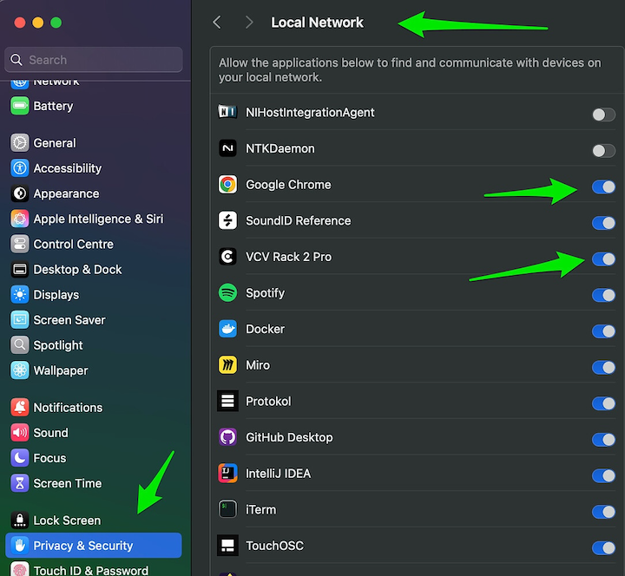](https://metamodule.info/docs/img/wifi-macos-permissions.png)
* **My browser won't load the Wi-Fi Expander's page**
  + Your computer must be on the same network as the Wi-Fi expander. Make sure whatever Wi-Fi network you entered into the ESP BLE app is the same as the network your computer is connected to.
  + Check the Wi-Fi Expander's light is green. If it's blue or red, then the Wi-Fi Expander is not connected to the network.
  + Check your system permissions and see if your web browser has permission to access the local network. See image above for an example in MacOS 15.
  + Eject the USB drive and/or microSD card and refresh the browser. If it connects now, then the issue may be that one of your disks contains too many files and the directory transfer is stalling out on the network. This is a known issue and the workaround is to reduce the number of files on all mounted disks.
* **I don't have a Wi-Fi button on my VCV Rack MetaModule hub**
  + You need to install the 4ms plugin for VCV Rack v2.0.9 or later
  + Make sure to quit and re-open VCV Rack after upgrading.
* **Other problems**
  + Make sure you are using the latest MetaModule firmware and Wi-Fi Expander firmware. Updating the MetaModule firmware while the Wi-Fi Expander is connected via the 8-pin cable will update both the MetaModule and the Wi-Fi Expander.
  + Use the latest version of the 4ms VCV Rack plugin.

**MetaModule MetaAIO Expander**

**Installation:**

1. Power off your system.

2. Connect one end of the included 10-pin cable to the header labeled “Audio

Expander” on the MetaModule, and the other end to the 10-pin header on the

MetaAIO expander.

3. 4. Make sure the red stripe is to the **right** on both ends of the cable.

Connect the included 16-pin power cable to Eurorack power. Make sure the red

stripe is facing **down.**

5. Power on your case. To check if the connection was successful, navigate to

Settings > Info. At the bottom of the screen under the word “EXPANDERS” it

should read “Audio/CV Expander connected.” Make sure to use firmware v1.6.7 or

later.

*(continued on other side)(continued from other side)*

**Usage:**

1. Navigate to a jack on MetaModule.

2. Click “New panel cable”

3. Select your desired input or output jack with the prefix “Exp.”

Questions? Need Help? **https://metamodule.info**